L.O: To compare the teeth of carnivores, herbivores and omnivores

Watch these video clips about different animals and their teeth:

https://www.bbc.com/bitesize/articles/z846gdm

https://www.bbc.com/teach/class-clips-video/science-ks2-teeth-how-they-help-animals-eat/zr8ygwx

Sort the animal skulls into groups (carnivores, herbivores and omnivores). Look carefully at the teeth. What might they eat? What animal might they be? What is different about the teeth in each group?

Steps to Success:
- Cut out the Headings
- Cut out each picture and put them in groups underneath each heading.
- Think about what animal you think it is.
- Think about what the animal might eat from the shape of their teeth.

Carnivores

Herbivores

Omnivores

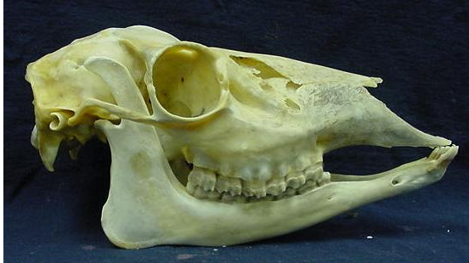
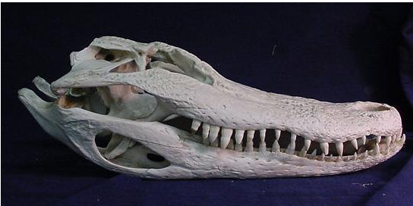
11
6
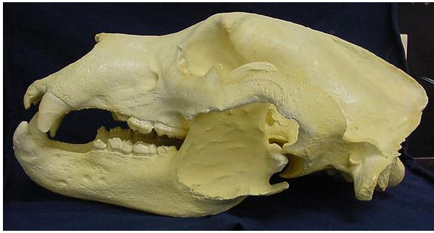
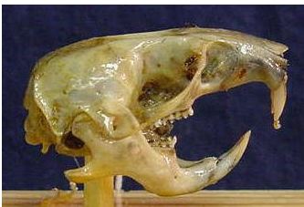
1
9

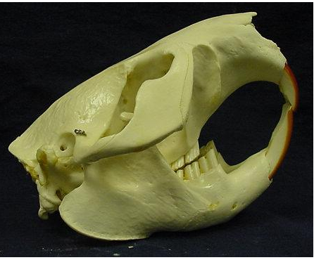
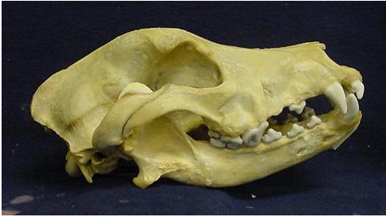
5
2

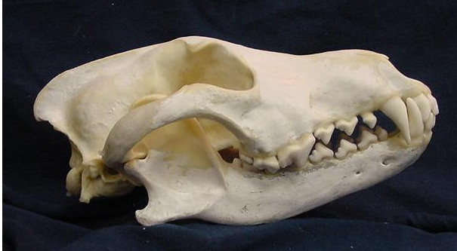
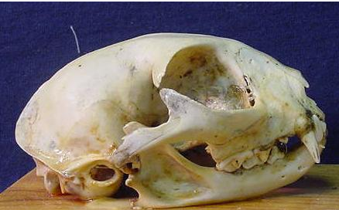
4
10

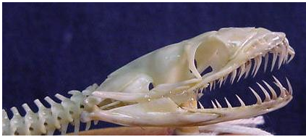
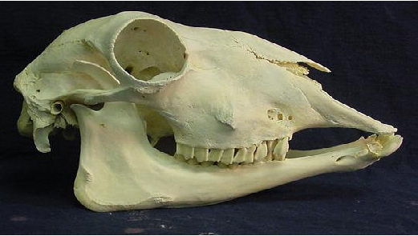
12
8

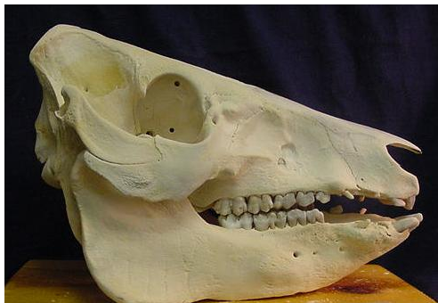
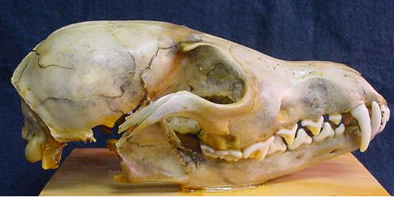
7
3

Answers
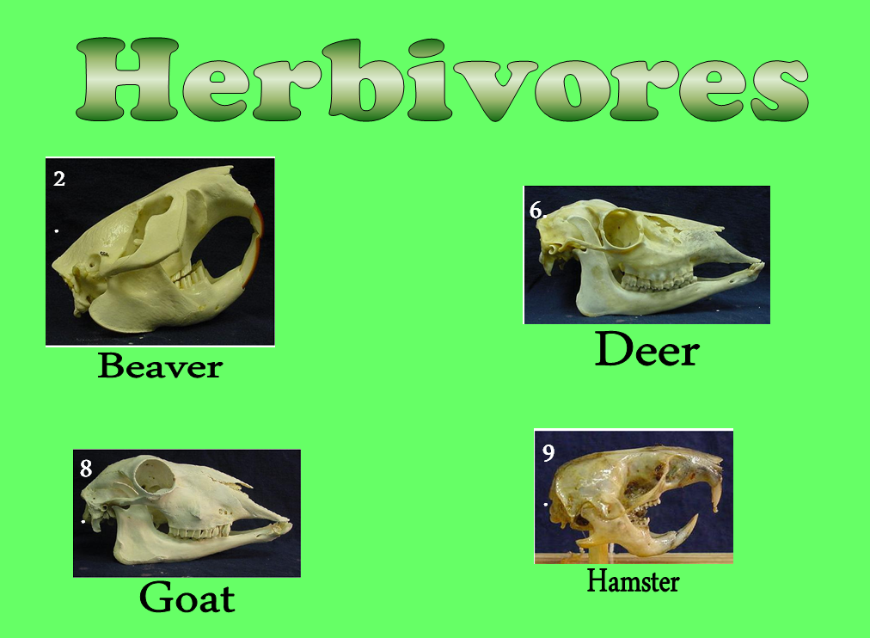

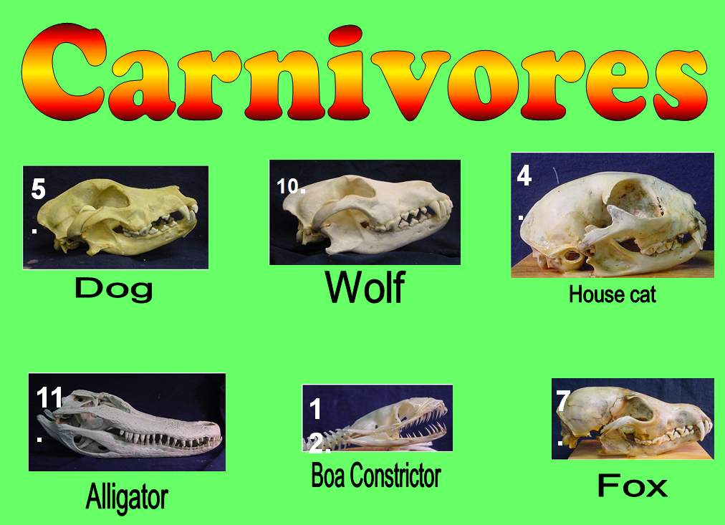

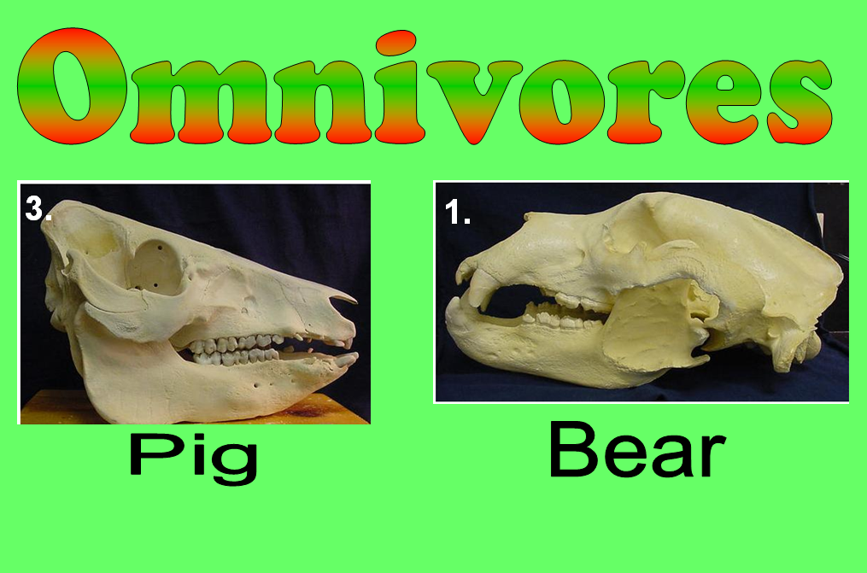

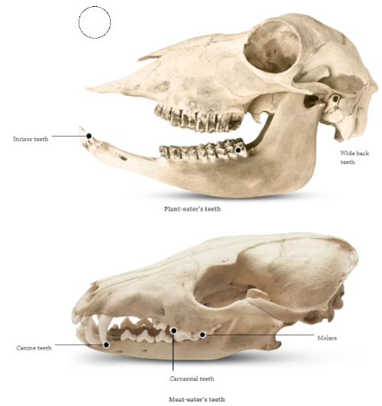
L.O To compare the teeth of carnivores, herbivores and omnivores.

Task
Fill in the missing words on the sheet.

The _________ of an animal`s teeth tells us what kind of food ` it eats. Horses, camels, cows, sheep and goats are ____________ which means they eat _________. They have rows of wide, _______ teeth for chewing grass, leaves and other tough plants. Lions, tigers, wolves and foxes are ___________ which means they eat ________. They have long, pointed teeth to grip their _____ and sharp teeth for cutting up meat. Carnivores do not have flat chewing teeth because they swallow their food in chunks. ______________ are animals that eat meat and plants so they have a mixture of sharp teeth and flat teeth.
` Word Bank
Herbivores Omnivores Carnivores Plants
Meat Prey Shape Flat

