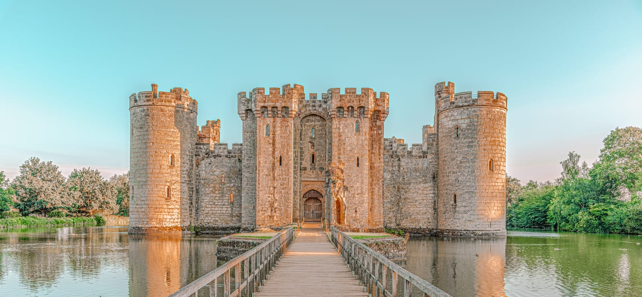
Main activity
B_____________________________
M_____________________________
R___________________T______________
A_____________L_________
Found around the castle, ______________
______________ were used to _____________
_________________________ _________________________ _________________________.
C________________W_______________
The job of the _______________________ ______________ was to _________________ _________________________________________
_____________________________________________.
G____________________D___________________
This area of the castle was often the _________________. The main gate or door was usually made from _____________________ so that ____
_____________________________________________
_____________________________________________.
M_________
An effective defence for the castle, __________ meant that ___________________________________________________________________________________________.

