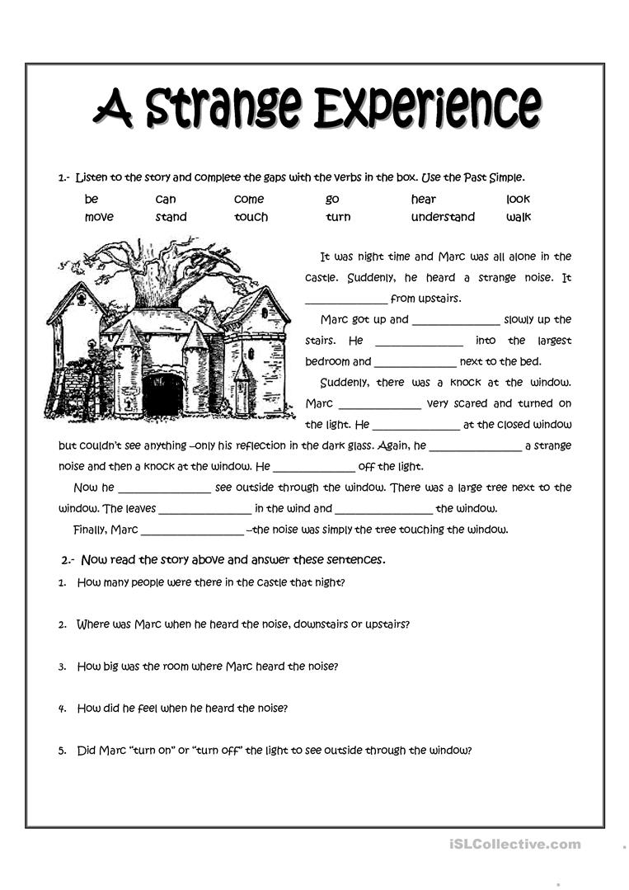
Monday 20th Blog y5.
Supported Reading comprehension

