

Easter Activities
Read through these activities and have a go.
Design a daily fitness circuit with 7 different tasks plus a water/rest station.  Remember to organise it so you have different activities to work on different muscles types and a range of cardio moves. It might be better to plan this around the garden and get the whole family involved! | Continents Project  Choose one or two countries within the continent. Find out about it’s rivers, language, landmarks, houses, industry, food and famous people.   | Quiz  Design a quiz for your family. You will need to think of a set of question and answers which can be grouped into categories. Perhaps you could include forfeits or bonus question ideas. Could you Skype or Facetime other family members and quiz them too? | Practise your 6,7,8 and 12 times tables  How fast can you recite them? Can you hold a family competition? Play on Hit the Button - focus on times tables, division facts and squared numbers  https://www.topmarks.co.uk/maths-games/hit-the-button | 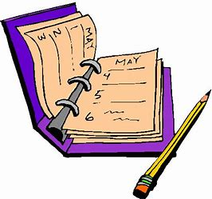  Diary  Can you record a written or video diary of your time in isolation? This will be something talked about in history lessons of the future!
Y5 Restaurant  Organise a restaurant in your home. Could you cook a meal or bake something for your family to share? | Portraits and Photography-    Take portrait photographs of their family members considering light and textures. Can you use the photographs to draw portraits in pen considering light and tone? | 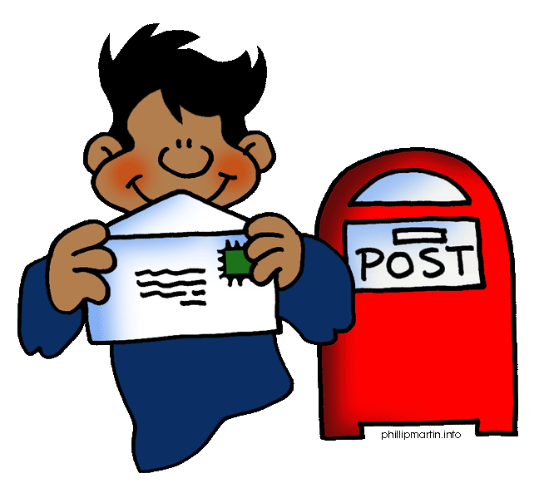  Hand Written Letters  Can you write a letter to a friend or a family member who you can’t see to cheer them up, perhaps you could include a picture or something you have made? | Organise an treasure hunt  There are lots on the internet to help but organise and write a scavenger hunt or a clue based treasure hunt for the whole family. | Can you create an Easter Garden?  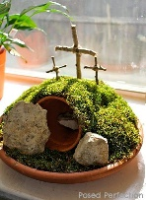  Many churches and places of worship create Easter Gardens to remember and celebrate the sacrifice Jesus made. Use the internet to inspire you.
Mapping Skills  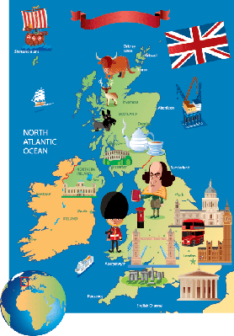  Identify the countries or cities within the UK, where your family members originate from or live. Can you plot these on a map? | Music  Write your own song/rap about what going on in your house at the moment. | Write an amazon book review.  What book have you read and loved recently? First write a book review and edit it before adding your own review on Amazon –*Please be mindful of protecting your identities online – never give out your full name or any personal details or information. | Time to Talk  Play a board game, facetime a member of your family, ask them to describe a favourite memory, or talk about what they liked to do when they were your age.  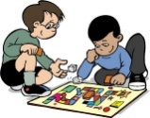 | Music from the Past Research music from the decade your parents, grandparents or other older family members were born. What were the most popular bands or singers during this time? Can you perform a song from this decade and create your very own dance routine? Maybe you could create a playlist for them.

