Upper Reedley - Donkey | Upper Reedley - Donkey | Upper Reedley - Donkey
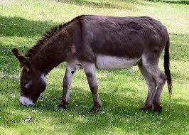  Visit a Library with an adult.  Explain who the ‘Children’s Laureate’ is what they do.  Research the author Hans Christian Anderson.  Write a diary entry as your favourite character or famous person.  Write a story where the main character is a donkey.  Write a book review of a fiction or non-fiction book. | 