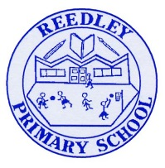
Year 5 Homework

Date homework set: 24.11.22
To be returned to school by: 29.11.22

Talking Topic (10 minutes)
- To discuss the following topic:

“What is a poem”
Tick when you have completed this task.
Maths (10 minutes)
Complete the following:

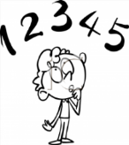
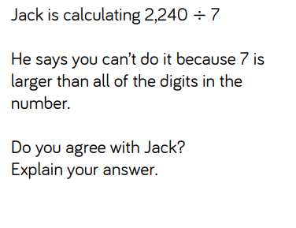

Tick when you have completed these tasks.
Writing (10 minutes)
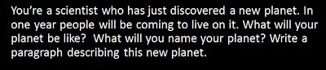

Spellings:
Learn these spellings and include them in your writing:
- Environment
- Community
- Develop
- Determined
- Physical


Tick when you have completed this task.

