

Talking Topic -5 minutes
“What does courage mean?”
Maths
Complete the two questions below and then log onto Maths whizz and complete three progressions.
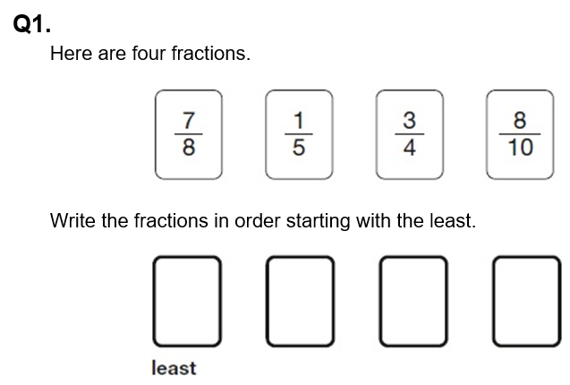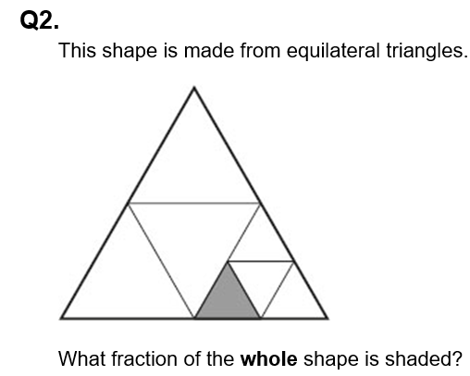
Log onto TTRS and go on studio to be able to move yourself up on the band ladder, then once your ready challenge yourself by taking part in the battle set by your teacher.
Completing this activity will help with SATs revision.
Reading 10 minutes. WRITE THESE IN YOUR READING JOURNAL AND GET PARENTS TO SIGN. Read to an adult or older sibling at least 3 times a week for 10-15 minutes. Get your reading record signed. We will be checking. Complete your reading for pleasure bookmark in the back of your Homework books to get the next award.
Spag 5 minutes. This week I want to practise the spellings below. Use the pyramid method to spell them and then correctly include them in a sentence.
There is also a task set on spag.com for you to complete.
Layout devices and paragraphing.
Completing this activity will help with SATs revision.
- accommodation
- appreciation
- completion
- communication
5. continuation
Online platform links
Here are links to the online platforms. Scan these with your device. All passwords are stuck in the front of your homework book.
Maths Whizz TTRS SPAG Purple Mash





Writing Task: Key skill- Informal language.

I want you to write an email as Julian, explaining to Jack how he felt starting at Beecher Prep School.

