Song Lyrics- First Verse
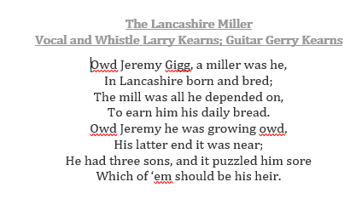
Music Appreciation
Oldam Tinkers
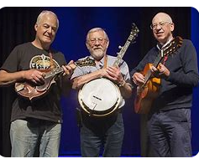
View | Seeing, looking or observing
Reflection | The image of something in a mirror or on any reflective surface
Bounces light | light that is bounced off a reflective surface onto the subject
Periscopes | Viewing apparatus
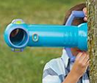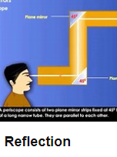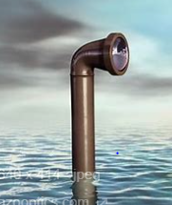
Science Vocabulary
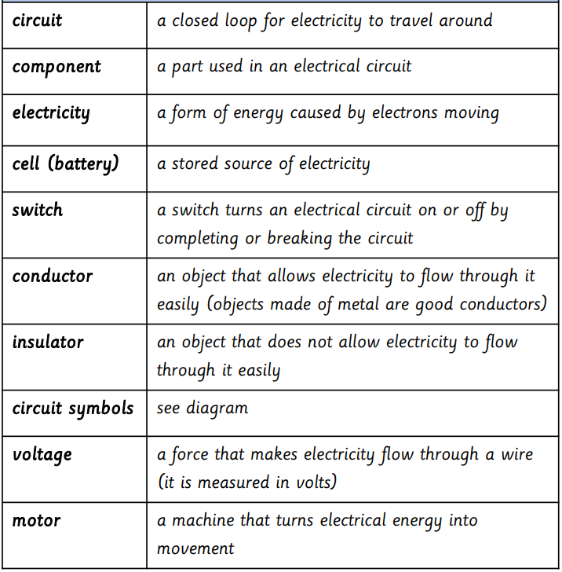

Geography

Geography Vocabulary | Meaning
Landscape | A large area of land, especially in relation to its appearance.
Grid reference | A map reference indicating a location in terms of a series of vertical and horizontal grid lines identified by numbers or letters
Rural | Characteristic of the countryside rather than the town
urban | Characteristic of a town or city, as opposed to the countryside or to a village:
