

Talking Topic -5 minutes
“Why is taking responsibility important?”
Maths
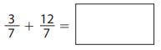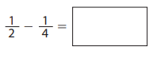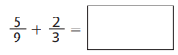
Log onto Maths whizz and complete three progressions.
Log onto TTRS and go on studio to be able to move yourself up on the band ladder, then once your ready challenge yourself by taking part in the battle set by your teacher.
Completing this activity will help with SATs revision.
Reading 10 minutes. WRITE THESE IN YOUR READING JOURNAL AND GET PARENTS TO SIGN. Read to an adult or older sibling at least 3 times a week for 10-15 minutes. Get your reading record signed. We will be checking. Complete your reading for pleasure bookmark in the back of your Homework books to get the next award.
Spag 5 minutes. This week I want to practise the spellings below. Use the pyramid method to spell them and then correctly include them in a sentence. Our spelling string to practise this week is: -cial
There is also a task set on SPag.com for you to complete.
Subject, verb agreement.
Completing this activity will help with SATs revision.
1. commercial 2. special 3. racial 4. facial 5. provincial
Online platform links
Here are links to the online platforms. Scan these with your device. All passwords are stuck in the front of your homework book.
Maths Whizz TTRS SPAG Purple Mash





Writing Task: Key skill- Passive voice.
I want you to write a short story about what is going on in the picture. Use your imagination, making sure the main character is the leopard and include different types of sentences.


