

Children at Reedley Primary School use the Internet on a regular basis as part of their learning.
In school, we have regular ‘Online Safety’ activities to remind children of the importance of keeping themselves safe online.
This term we have looked at suitable search engines that we can use when finding information on the internet.
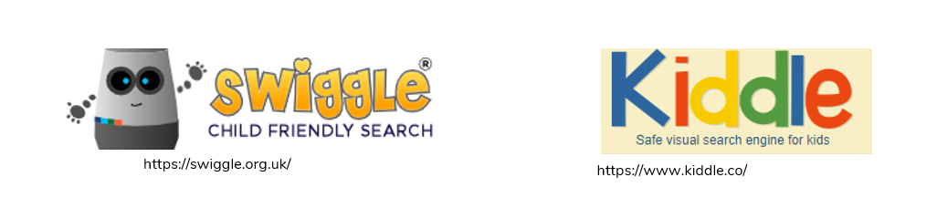
We use the kiddle web browser in our school to help us support our learning and when searching information. In our online safety lessons, we thought about using keywords to help us to find information rather that writing long sentences or questions.
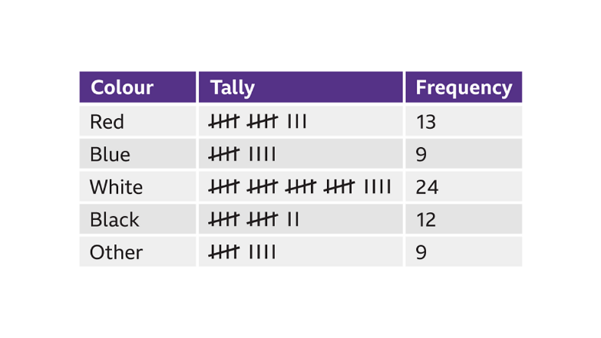
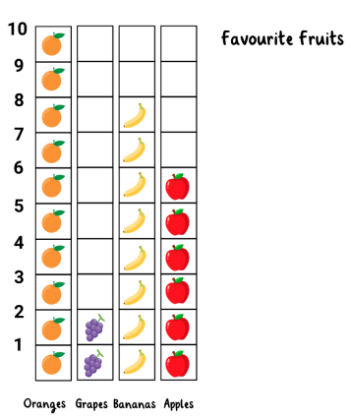

This term as part of the computing curriculum, Year 2 children explored how to ask questions to collect useful information. We organised data using tally charts, pictograms, and simple branching databases to help sort and identify objects.

