Upper Reedley - Argentina | Upper Reedley - Argentina | Upper Reedley - Argentina
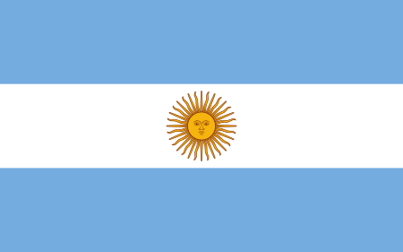  Find out two facts about the flag of Argentina.  Research four animals that are native to Argentina.  Draw a special landmark or building in Argentina.  Use an atlas. Write down three places to visit in Argentina.  Write the titles of three children’s books by an Argentinian author.  Find three interesting facts about Argentina – share them with a friend. | 