
Year 6 Homework

Date homework set: 14.01.26
To be returned to school by: 19.01.26

Talking Topic To discuss the following topic:
“How can we keep safe online?” Tick when you have completed this task.
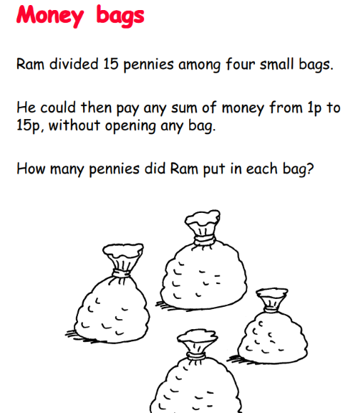
Maths
Maths Whizz
Complete ten minutes on Maths Whizz.
This will help with SATs revision.


Spag.com : There is also a task set on SPag.com for you to complete.

Spellings
Investigate four of the Year 5 and 6 spellings below. Write them in ‘pyramids’ or with rainbow writing to help you remember how to spell them
1. dessert 2. Desert 3. Stationary 4. Stationery 5. Complement. 6. compliment
Writing: Think about how you feel while resting (think about how fast your heart is beating, how heavy you are breathing and how you ‘generally’ feel).
Now do an exercise (such as 10 star jumps, burpees or jogging on the spot). How do you feel now? Write a paragraph comparing and contrasting how you feel before and after doing physical activity.
Online platform links
Here are links to the online platforms. Scan these with your device. All passwords are stuck in the front of your homework book.
Maths Whizz TTRS SPAG Purple Mash




