Talking Topic -5 minutes: “What does the word empathy mean?”
Maths -10 minutes . I want you to answer the questions below.
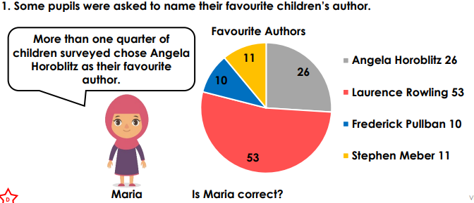
Log onto Maths whizz and complete three progressions.
Log onto TTRS and go on studio to be able to move yourself up on the band ladder, then once your ready challenge yourself by taking part in the battle set by your teacher.
Completing this activity will help with SATs revision.
Reading 10 minutes: WRITE what you have read in your READING JOURNAL AND GET YOUR PARENTS TO SIGN YOU HAVE READ
Read to an adult or older sibling at least 3 times a week for 10-15 minutes. Get your reading record signed. We will be checking. Complete your reading for pleasure bookmark in the back of your Homework books to get the next award.
Spelling:5 minutes. This week I want to practise the spellings below. Use the pyramid method to spell them and then correctly include them in a sentence.
Spag: Complete the Spag.com activity.
Make sure you have a go at answering all the questions. It should only take you five minutes.
1.Parliament 2. Persuade 3. physical 4. prejudice
5. privilege


Online platform links. Here are links to the online platforms. Scan these with your device. All passwords are stuck in the front of your homework book.



Maths Whizz TTRS SPAG Purple Mash

Writing Task: Key skill- pronouns. Write a paragraph explaining how the scarecrow is feeling about not having a brain. Make sure your sentences make sense and you are including pronouns.

