Data Summer 2025
Overview of school data from the end of 2024 – 25. Further details are shown below.
- Year 6 SATs Reading, Writing and Maths Combined at expected level
- Year 6 SATs Reading, Writing and Maths Combined at higher level
- Y4 Multiplication Check
- Phonics - Year 1
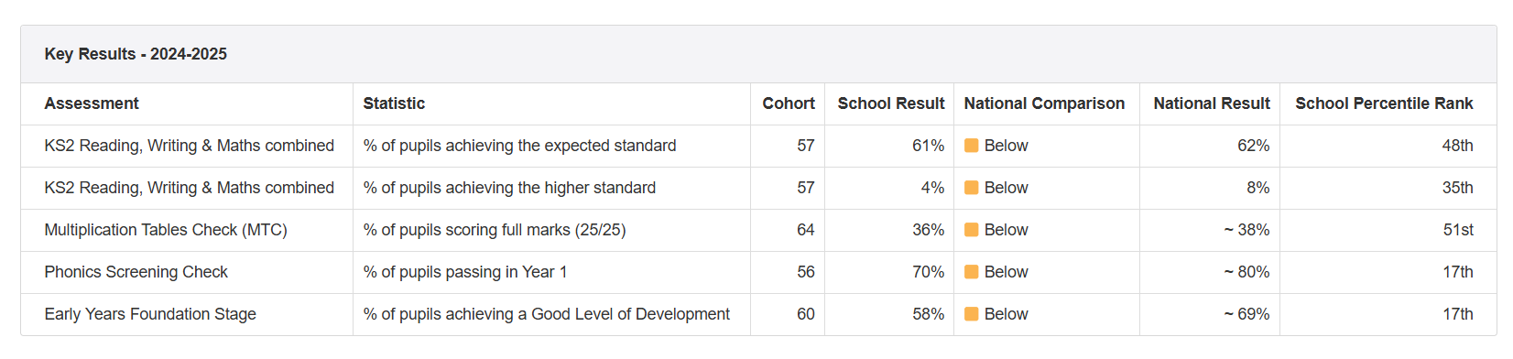
- EYFS

Results in more detail
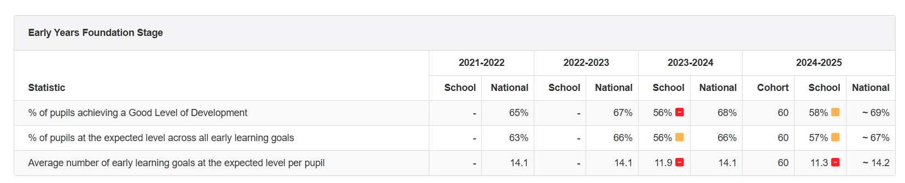
EYFS

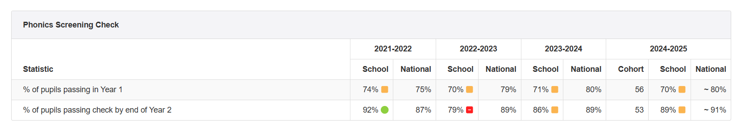
Y1 and Y2 Phonics

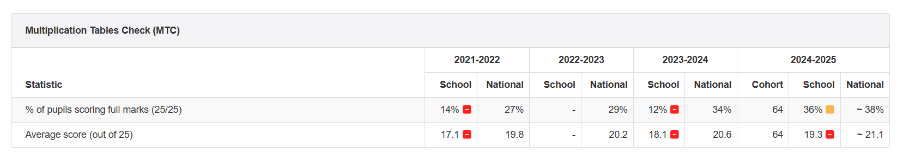
Year 4 Multiplication Check

Key Stage 2
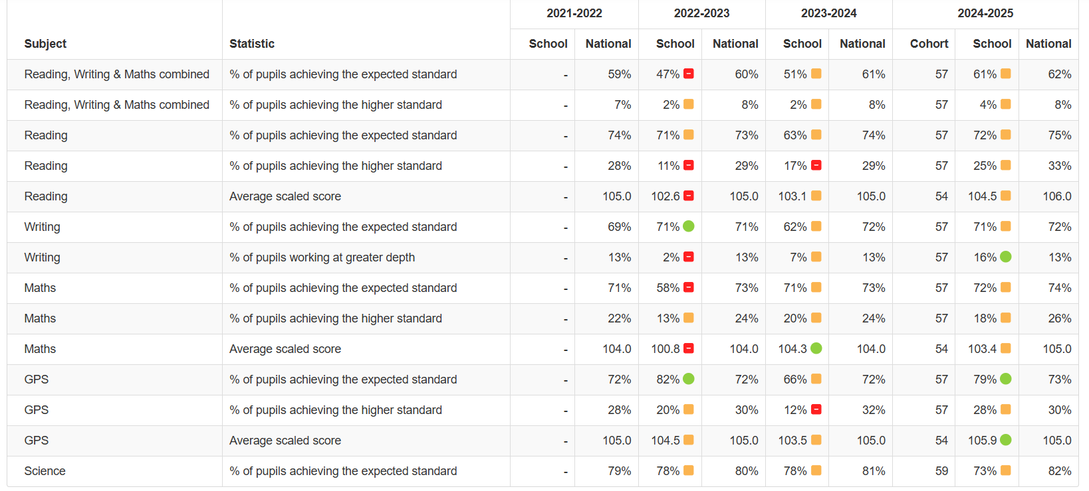

Policy Changes
2024

