Vocabulary |  |  | Ring-a-ring o’ roses,  A pocket full of posies,  A-tishoo! A-tishoo!  We all fall down. | A Plague Doctor
Gout | Inflammation due to build-up of uric acid in tissue. |  |  | A plague doctor treated victims of the bubonic plague. In times of epidemics, such doctors were specifically hired by towns where the plague was.  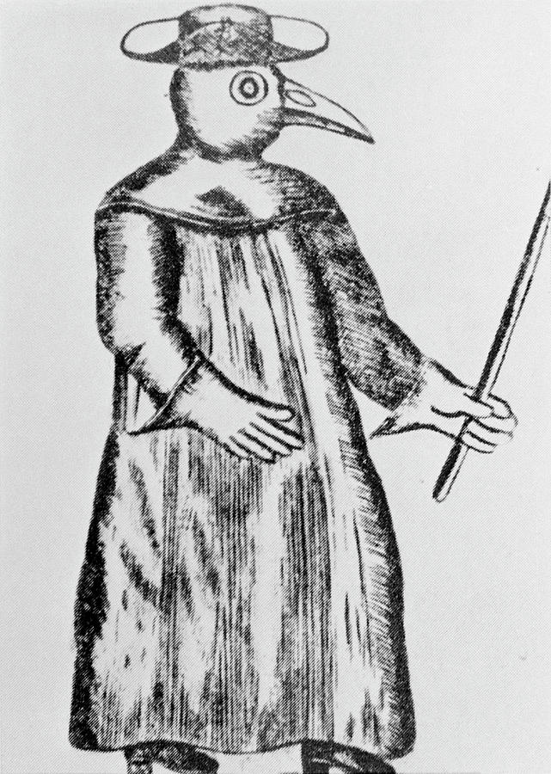
Jaw Faln | Lockjaw, also known as tetanus
Lethargy | Sleeping sickness.
Plague | A contagious bacterial disease with the formation of buboes (bubonic plague) and sometimes infection of the lungs (pneumonic plague).
Surfet | Vomiting from over eating. |  | Epidemic and pandemic
Bubonic Plague | - The commonest form of plague in humans, characterized by fever, delirium, and the formation of buboes. |  | An epidemic occurs when a disease affects a greater number people than is usual for the locality or one that spreads to areas not usually associated with the disease. A pandemic is an epidemic of world-wide proportions.
Pneumonic Plague | Pneumonic plague is a severe lung infection. Symptoms include fever, headache, shortness of breath, chest pain, and cough.
Pneumonic Plague |  |  | The Great Plague was also known as the Black Death.
Facts |  | City that was affected
- The Great Plague occurred between 1665 and 1666.  - People were terrified of the plague – just 300 years earlier it had killed millions.  - It’s no wonder people were so scared – the plague killed people at an alarming rate and victims died within days of catching the illness.  - Some doctors believed that bad poisonous air was the cause of the plague, infecting anyone who breathed it.  - The cause of the plague was also blamed on livestock carrying the disease while others believed it to be a punishment from God.  - The real root of the problem was RATS! What people did not understand was that the plague was a disease found in black rats. Fleas would bite the rats and become infected and the infected fleas would then spread the disease to humans. |  | 

