Historical vocabulary
Evacuated | To move people from a dangerous place
censorship | Prohibition of speech or writing that is deemed to overthrow or undermined an established system.
propaganda | communication that is primarily used to influence or persuade an audience
Home front | It is commonly used to describe the full participation of the British public in World War II who suffered raids and endured food rations as part of what came to be called the "Home Front".
blitz  Science, Circulatory system | A sudden, swift, and overwhelming military attack, usu. using tanks and aerial e.g. The Blitz, the intensive aerial bombing of British cities by the Germans .
Why did Britain go to war In 1939?
Britain and France declare war on Germany On September 3, 1939, in response to Hitler’s invasion of Poland, Britain and France, both allies of the overrun nation declare war on Germany.
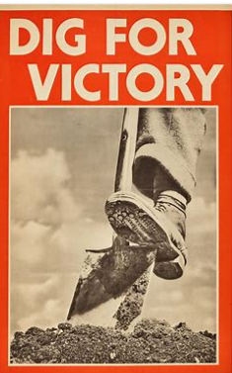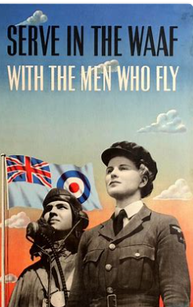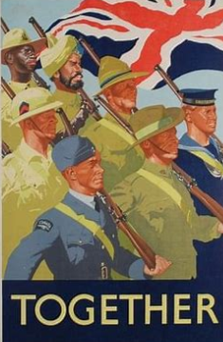
Artist - Henry Moore
Key Vocabulary | Word Meaning
Tone | This refers to the lightness or darkness of something.
Shade | A shade is where an artist adds black to a colour to darken it down.
Line | Line is a path left by a moving point.
Shape | A shape is an area enclosed by a line. It could be just an outline or it could be shaded in.
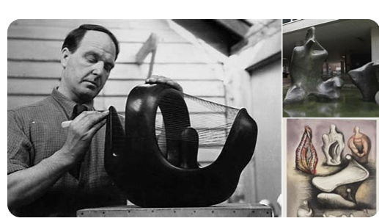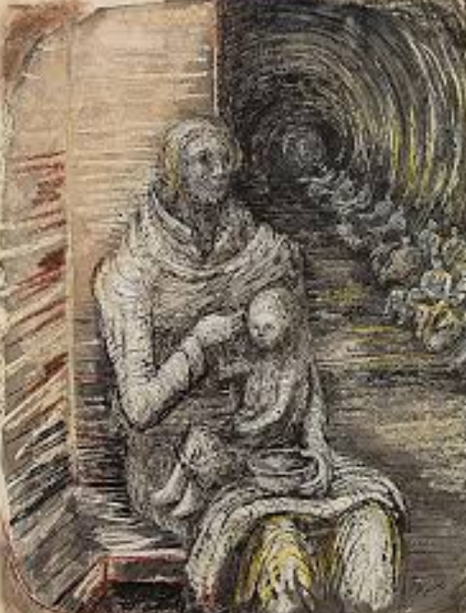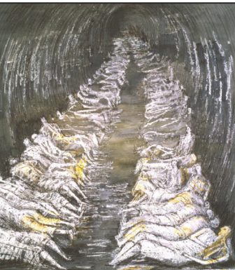

circulatory system | The blood circulatory system is a  system of organs that includes the  heart, blood vessels, and blood which is circulated throughout the entire body of a human or other vertebrate.
blood | The red liquid that circulates in the  arteries and veins of humans and other  vertebrate animals, carrying oxygen to  and carbon dioxide from the tissues of the  body:
blood vessels
Artery | A
Vein

heart rate

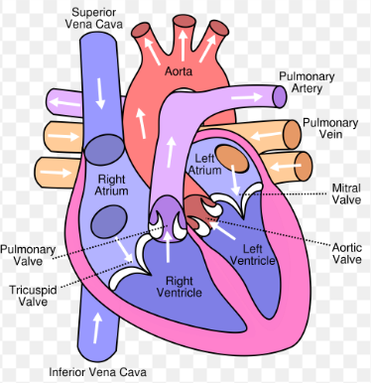
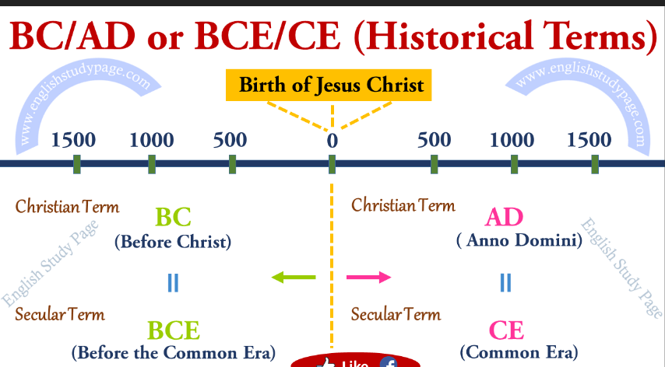

A vein is an elastic blood vessel that transports blood from various regions of the body to the heart.
The blood vessels are the components of the circulatory system that transports blood. .throughout the human body.
A vessel that carries blood high in oxygen content away from the heart to the farthest reaches of the body.

