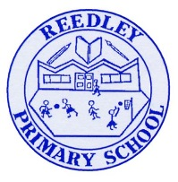
Year 5 Homework

Date homework set: 06.01.22
To be returned to school by: 11.1.22
When completing your homework try and do a little every day and not all at once.

Talking Topic

- To discuss the following topic:
- “What do you know about space?”
Tick when you have completed this task.
Maths Complete the Roman Numerals task on My Maths.

- Times tables Rock Stars.
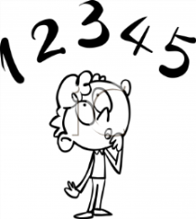
Tick when you have completed these tasks.
Reading

- Read the next chapter from your new reading for pleasure book.
- Read a book on Bug Club
- Continue with your next book mark.
- Read to an adult and ask them to sign your Reading Diary. Your reading diary will be checked.
Tick when you have completed this task.


Spelling
Practice this weeks spellings.
Physical
Occur
Temperature
Recommend
Sacrifice

Tick when you have completed this task.
Spag. Complete the spag.com activity- Grammar Y5 B

Writing:
Imagine you have landed on Mars. I want you to write what you can see. Use expanded noun phrases to make your description come to life.


Tick when you have completed this task.

