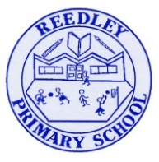
Year 5 Homework

Date homework set: 09.12.24
To be returned to school by: 17.12.24

Talking Topic
- To discuss the following topic:

- “Who celebrates Christmas?”
Tick when you have completed this task.
Maths Complete and learn the following;
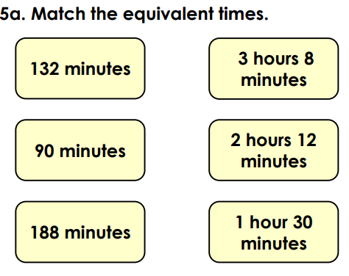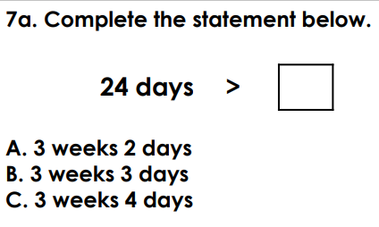
- Times tables Rock Stars.
- Complete three steps on Maths Whizz.
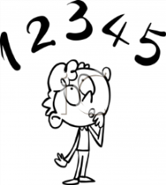
Tick when you have completed these tasks.
Reading

- Read the next chapter from your new reading for pleasure book.
- Continue with your next book mark.
- Read to an adult and ask them to sign your Reading Diary. Your reading diary will be checked.
Tick when you have completed this task.

Spelling: Learn this week’s spellings and include each one in a sentence.
Defensive
Refine
Microscope
Telescope.
Tick when you have completed this task.
Spag.com

Complete the activity below on Spag.com.
Complete relative clauses.
Writing: I want you to write a letter to the Jabberwocky explaining why he is not a nice person.
Tick when you have completed this task.

