
Year 5 Homework

Date homework set: 14.9.23
To be returned to school by: 19.9.23

Talking Topic
- To discuss the following topic:

“What is our value this week?”
Tick when you have completed this task.
Maths : On My Maths, complete Estimates with decimals. Home - MyMaths
- Learn the following
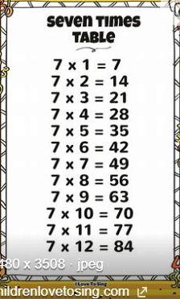
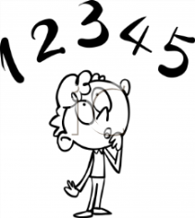
Tick when you have completed these tasks.
Reading

- Read the next chapter from your new reading for pleasure book. Ask someone to listen to you read.
- Complete your next bookmark.
Tick when you have completed this task.
Spelling : Learn this week’s spellings. Include them in a sentence.
Thought

Throughout
Cough
enough
Tick when you have completed this task.
Spag. Complete the activity on SPAG. Com. Expanded noun phrases. https://www.spag.com
Writing
- I want you to write a description about Gelert. Your grammar focus is including an ‘…ed’ clause at the start of a sentence.
Reminder:
If you would like extra homework there are more activities on:
Times Tables Rock Stars – Times Tables Rock Stars (ttrockstars.com)
ActiveLearn: Login (activelearnprimary.co.uk) (Bug club)
https://whizz.com/

