
Year 5 Homework

Date homework set: 21.01.2025
To be returned to school by: 27.1.25
When completing your homework try and do a little every day and not all at once.

Talking Topic : To discuss the following topic:

- “What do you know about Mozart?”
Tick when you have completed this task.
Maths: Complete the next 3 steps on Maths Whizz
Answer the questions below.
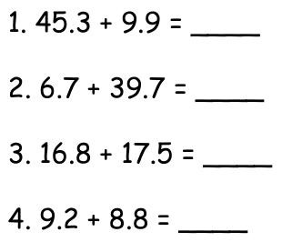
- Times tables Rock Stars.
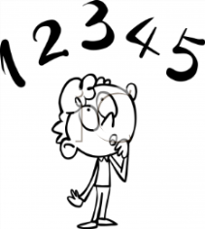
Tick when you have completed these tasks.

Reading
- Read the next chapter from your new reading for pleasure book.
- Continue with your next book mark.
- Read to an adult and ask them to sign your Reading Diary. Your reading diary will be checked.
Tick when you have completed this task.

Spelling : Practice this week’s spellings and include them in a sentence.
Tick when you have completed this task.
- category
- cemetery
- committee
- communicate
Spag. Complete the spag.com activity- Grammar Y5 C
___________________________________________________________________
Writing: Imagine you are an alien. Our world would seem very strange to you. Write a paragraph about an alien trying to figure out what we use a mop for.

