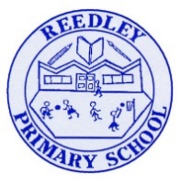
School Council Newsletter December edition

Nativity
School Council wanted to say a big well done to Reception, Year 1 and Year 2 for their fantastic nativity performance. We really enjoyed watching it.
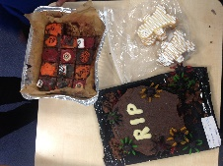
Great Reedley Bake Off
Our Great Reedley Bake off was a massive success. We had lots of entries. We were the judges and it was the best job ever! We had to taste them all!! Here are pictures of the winning entries.

Christmas fair
We wanted to say a big thank you to Mrs Iqbal, Mrs Daar and the staff for such a good Christmas Fair. This helped school to raise much needed money for resources, so thank you for supporting us with this.
Raffle prizes
We wrote to different companies to get donations for our raffle and we had a fantastic response. We will be doing this in the future so if you know of any local companies that would be willing to donate please let Mrs Iqbal know.
Thank you to everyone that donated.
Cooking donations
We do lots of cooking in school as part of our DT projects but we are really struggling for equipment. We would be very grateful for any donations of utensils, pans, baking trays, mixing bowls etc…
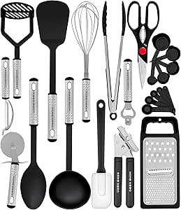
These would need to be in good condition so that they are safe for us to use. If you would like to have a clear out and donate please pass them to Mrs Iqbal in the office.

Holiday homework
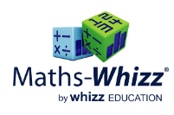

The teachers have asked us to remind you of the online platforms that we can go on over the Christmas break. Battles have been set on TTRS, tasks are set on Maths Whizz and you could also read your reading books too.
We would like to wish everyone Happy Holidays and a Happy New Year from the School Council members, Juwayriya, Zakariyah, Alayna, Eesa, Aisha, Hashim, Dua and Yousaf.

