Thursday 9th January 2025
KL – To make simple inferences
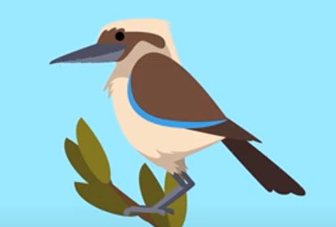

How is kookaburra feeling?
__________________________________________
__________________________________________
__________________________________________

What is Kookaburra thinking?
__________________________________________
__________________________________________
__________________________________________

What might kookaburra say?

_________________________________________
_________________________________________
_________________________________________

Thursday 9th January 2025
KL – To make simple inferences
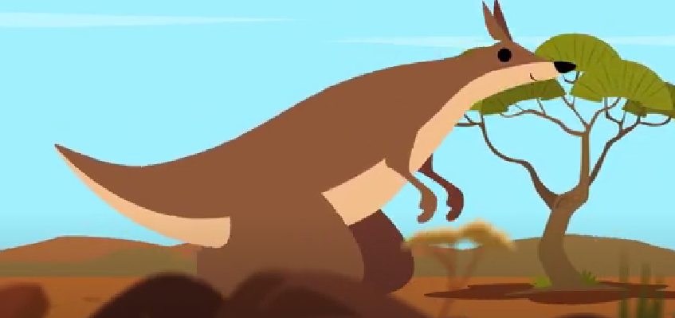

How is kangaroo feeling?
__________________________________________
__________________________________________
__________________________________________

What is kangaroo thinking?
__________________________________________
__________________________________________
__________________________________________

What might kangaroo say?

_________________________________________
_________________________________________
_________________________________________

