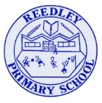
Reception Homework

Phonics - Learn ‘J’
In Reception we are now beginning Phase 3 Phonics. You can go on YouTube and watch both videos together. Search…
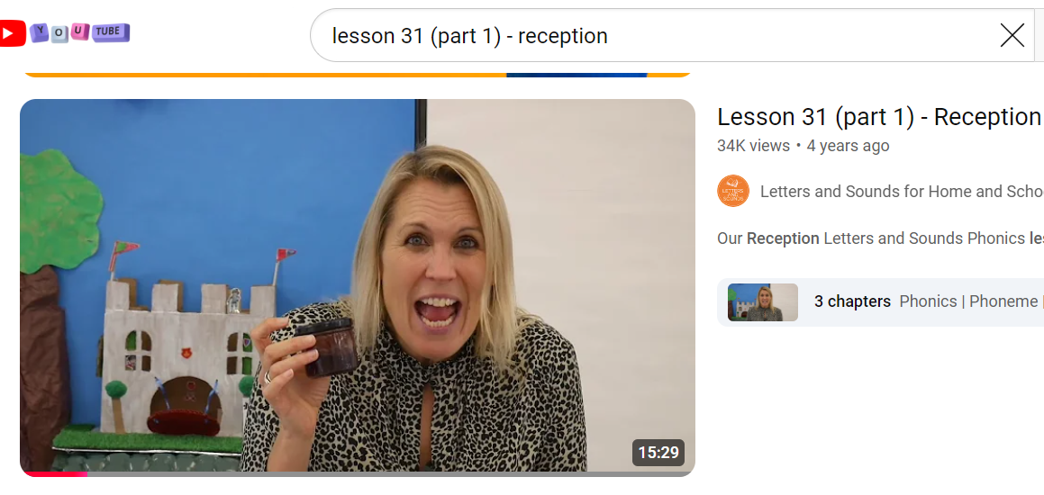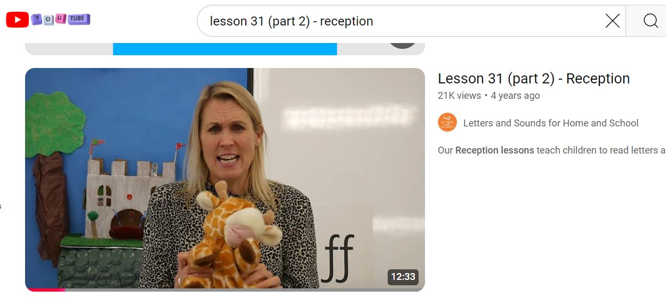
Tricky Words
Begin to learn the Phase 3 Tricky words. Remember you can not sound these out. We must learn to read them by sight.
be
Literacy
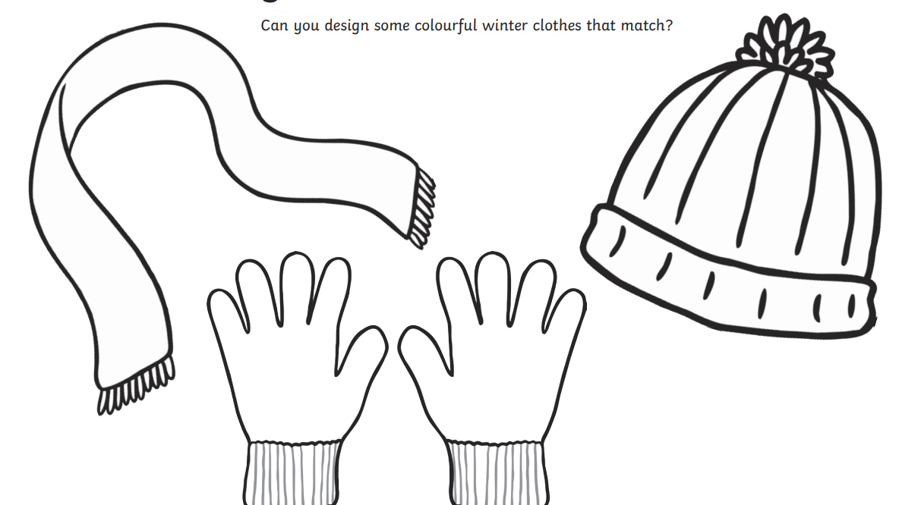
- Draw and design colourful winter clothes.
- Think of words to describe them.
- Label them (e.g., red, soft) or write a sentence (e.g., The hat is bloo.) Remember to sound your words out.

Number Formation (Rhymes are below)
In the homework books/outside children trace/copy writing the numerals from 0 to 9 with a variety of writing implements and surfaces such as table, easel, flat wall and floor. Children to practise writing the numerals with which they find difficulty. Adult prompt(s):Where do you put your pencil to start? Which way do you move your pencil? Can you say the rhyme?
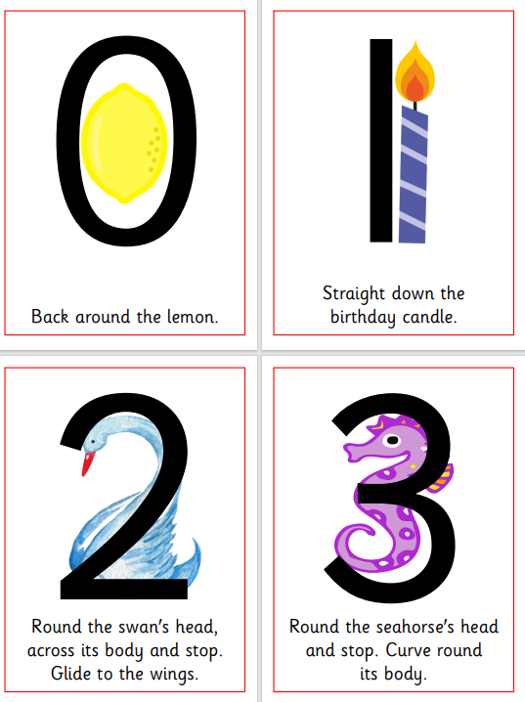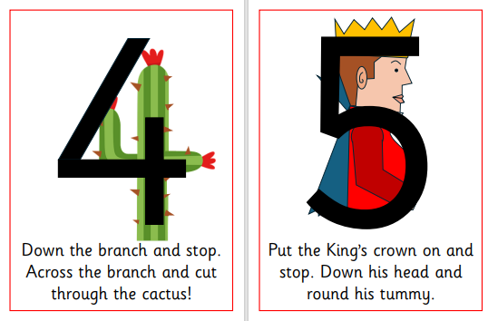
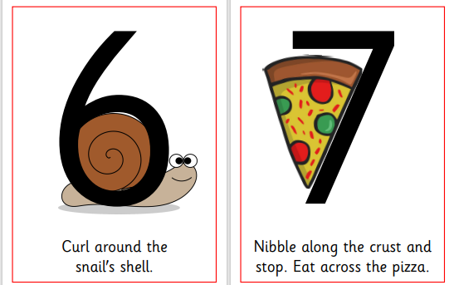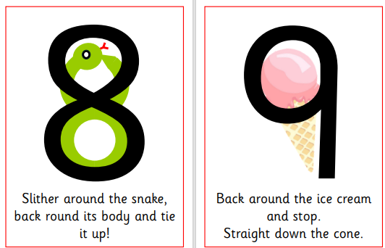
Reading Read your home reading books today.

