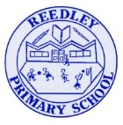
Reception Homework

Phonics - Learn ‘W’
In Reception we are now beginning Phase 3 Phonics. You can go on YouTube and watch both videos together. Search…
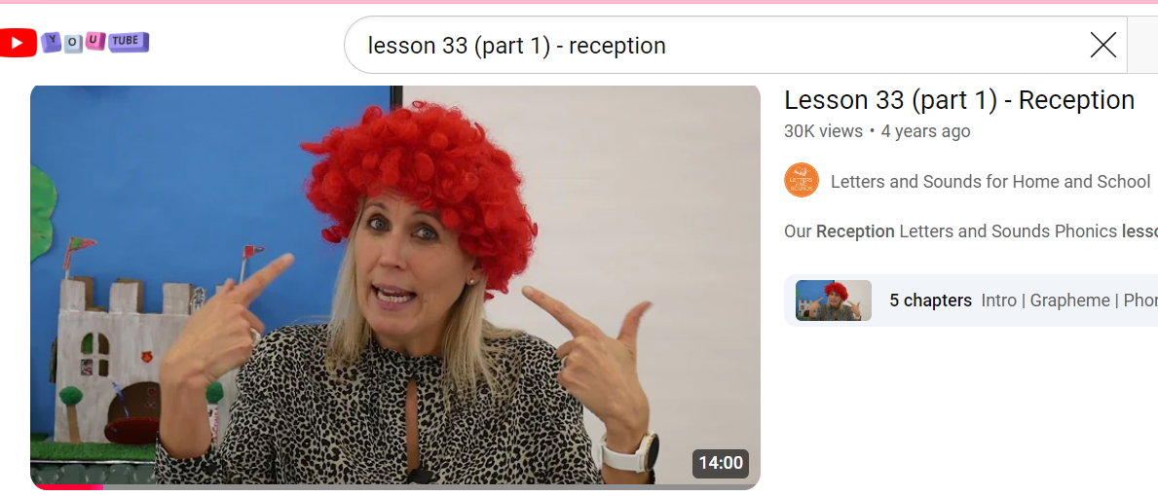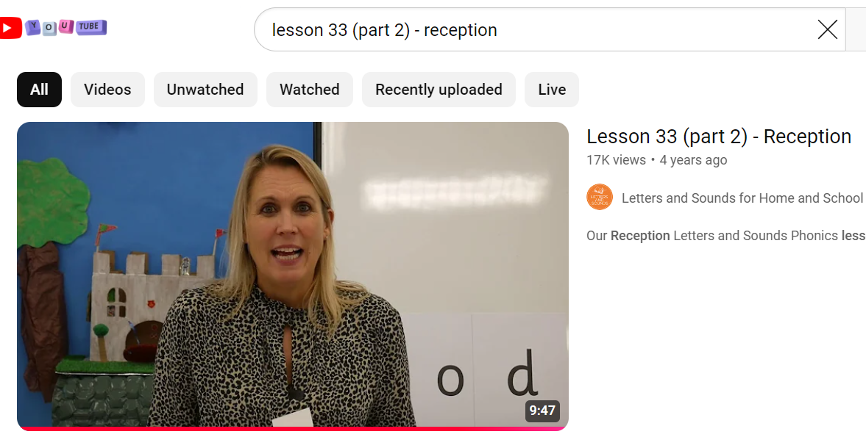
Tricky Words
Begin to learn the Phase 3 Tricky words. Remember you can not sound these out. We must learn to read them by sight.
be we
Literacy
We are going to explore the season Winter!
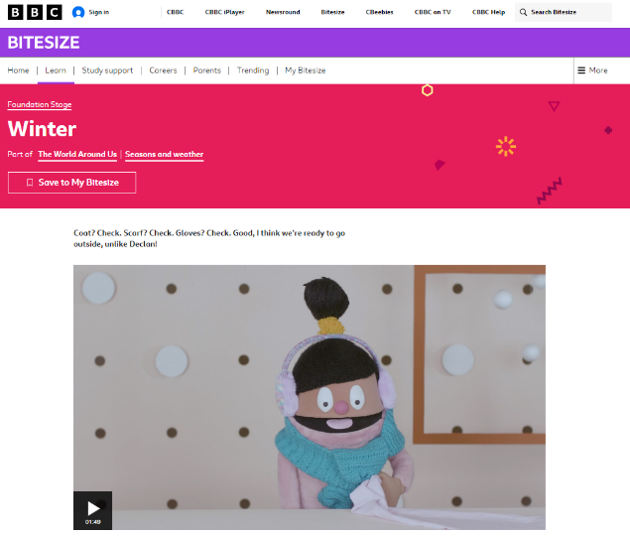

- What is a season? Do you know any other seasons? Talk about what the weather is like in winter. Can you see any signs of winter today?
- Watch this video all about winter. Winter - BBC Bitesize
- You can also watch this video. Bing Videos
- What did you learn?

Mystery Boxes (Or anything else that can hide the item such as cushions or books)
Have five identical boxes and fill each with a different number (to 10) of the same item such as beads/pasta on string. Each box should be opaque and closed. Children select two boxes and shake to identify which box has more and which box has fewer. They can check by opening the boxes and counting/lining up. Adult prompt(s):Which box do you think has more/fewer? Why? How can you check? Would the amount that has more be a longer line or a shorter line? How can you compare these two amounts? ... is more than ... and ... is fewer than ... (say it two ways)

Reading Read your home reading books today.

