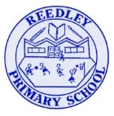
Reception Homework

Phonics - Learn ‘V’
In Reception we are now beginning Phase 3 Phonics. You can go on YouTube and watch both videos together. Search…
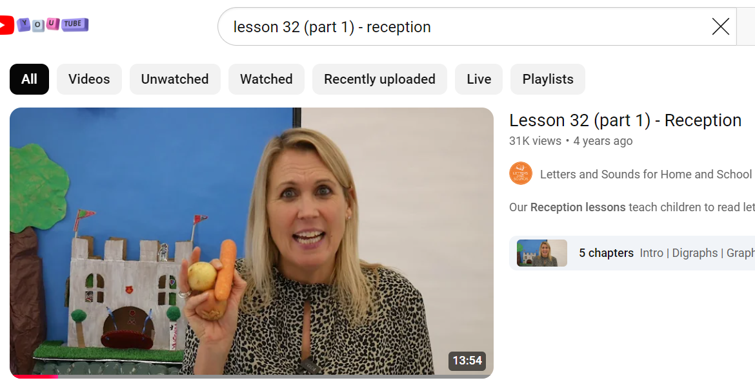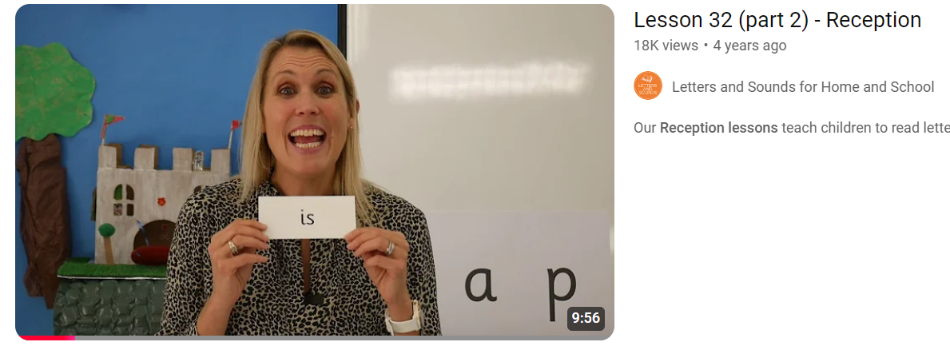
Tricky Words
Begin to learn the Phase 3 Tricky words. Remember you can not sound these out. We must learn to read them by sight.
be
Literacy


On Tuesday you thought of lots of words to describe the snow scene (cold, white, frosty, crisp, frozen, freezing) and practised saying sentences.
- Practise adding your favourite words into the sentence ‘It is _____ and _____.’ Can you say it 3 times?
- Count the words in your sentence.
- Write the sentence using your phonics fingers to hear all of the sounds.

Maths
The Taller Tower Challenge (Construction/Building Blocks)
Put a 30 second sand timer on. Race to see who can build the taller tower within the time. Adult prompt(s): Who has made the taller tower? How can you check without counting? How many blocks are in the taller tower? How many are in the other tower? How can you compare these two numbers? Which tower has more bricks? Which tower has fewer bricks? Would a tower with 9 bricks be taller or shorter than this tower? Why? (because 9 is more/fewer than ...)

Reading Read your home reading books today.

