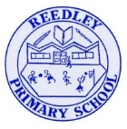
Reception Homework

Dinosaur Detectives
Look through your knowledge organiser which was sent home before the break – check your child’s understanding of these key words, people and phrases.
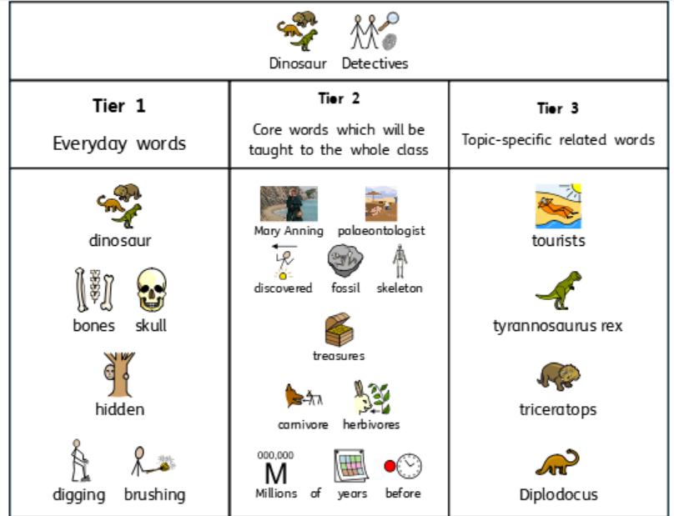
Literacy
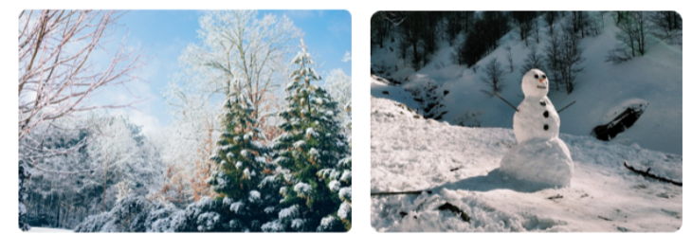
- Discuss words to describe the snow they have seen. What does it look like? What does it feel like?
- Then draw/paint a winter scene for example, making a snowman.
- Think of words/phrases to describe your scene for example, ‘The snow is thick and crisp’ or ‘The snowman is round’.
- Your child or yourself can label your picture.

Tricky Words
Read these. Then think and talk about sentences you would use these in for example, “I can see a fossil”.
the I to no go into

Numberbonds
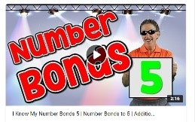
Children in Reception need to know how to make numbers to 10 by adding two numbers together. Adults ask, ‘How do you make 1-10?’ and then ask, ‘Is there another way?’. There are ‘I know my number bond songs’ on YouTube by Jack Hartmann which can also help.
1 | 2 | 3 | 4 | 5
1 + 0 | 2 + 0 | 3 + 0 | 4 + 0 | 5 + 0
 | 1 + 1 (or double 1) | 2 + 1 | 3 + 1 | 4 + 1
 |  |  | 2 + 2 (or double 2) | 3 + 2
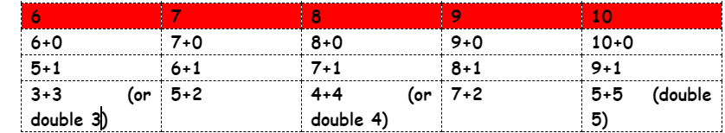

Reading Read your home reading books today.

