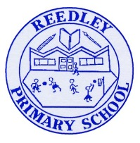
Year 5 Homework

Date homework set: 4.12.24
To be returned to school by: 10.12.24

Talking Topic - To discuss the following topic:

“What does advent mean?”
Tick when you have completed this task.
Maths Complete and learn the following; Find the area of the two shapes below and complete the next three steps on Maths Whizz.
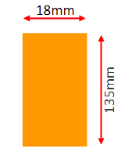
- Times tables Rock Stars.
- Learn your 8 times tables.
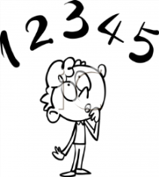
Tick when you have completed these tasks.

Reading Read the next chapter from your new reading for pleasure book.
- Continue with your next book mark. Remember when you have completed your book mark, you will receive a certificate and your name will be read out in Friday’s assembly.
- Read to an adult and ask them to sign your Reading Diary.
Tick when you have completed this task.

Spelling - Practice the spellings below, using the pyramid method.
beautiful
difference
vegetable
interrupt
Tick when you have completed this task
Spag. Complete the activity.
On Spag.com camplete the suffixs and prefixes.
Writing. Key skill- relative pronoun – which.

Write a list of instruction to make soup.

Tick when you have completed this task.

