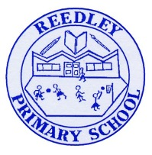
Year 5 Homework

Date homework set: 27.11.24
To be returned to school by: 3.11.24

Talking Topic - To discuss the following topic:

“What is the Jabberwocky?”
Tick when you have completed this task.
Maths Complete and learn the following;
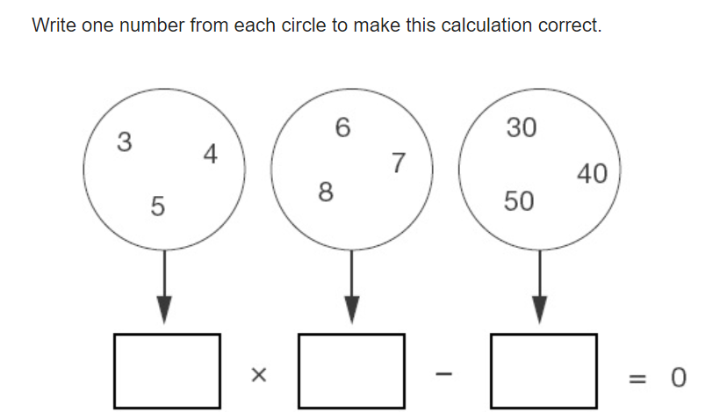
- Complete three steps in Maths Whizz
- Times tables Rock Stars.
- Learn your 9 times tables.
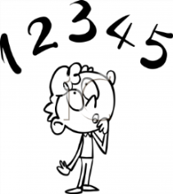
Tick when you have completed these tasks.
Reading

Read the next chapter from your new reading for pleasure book.
- Continue with your next book mark. Remember when you have completed your book mark, you will receive a certificate and your name will be read out in Friday’s assembly.
- Read to an adult and ask them to sign your Reading Diary.

Tick when you have completed this task.
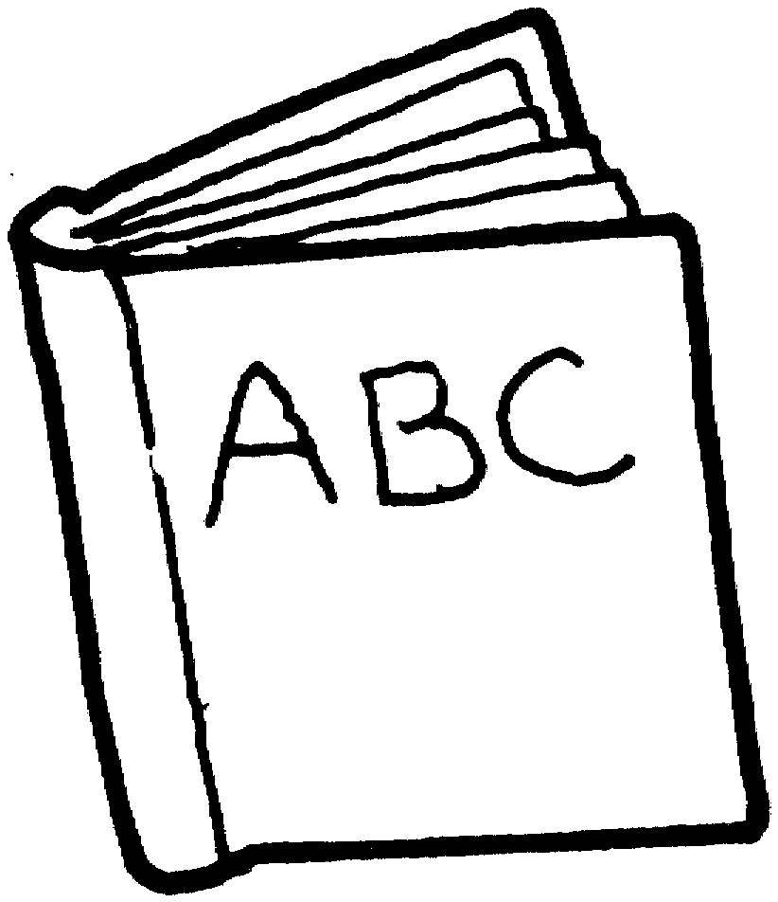
Spelling - Practice the spellings below.
suggest
system
average
symbol
vehicle
Tick when you have completed this task.

Spag. Complete the activity.
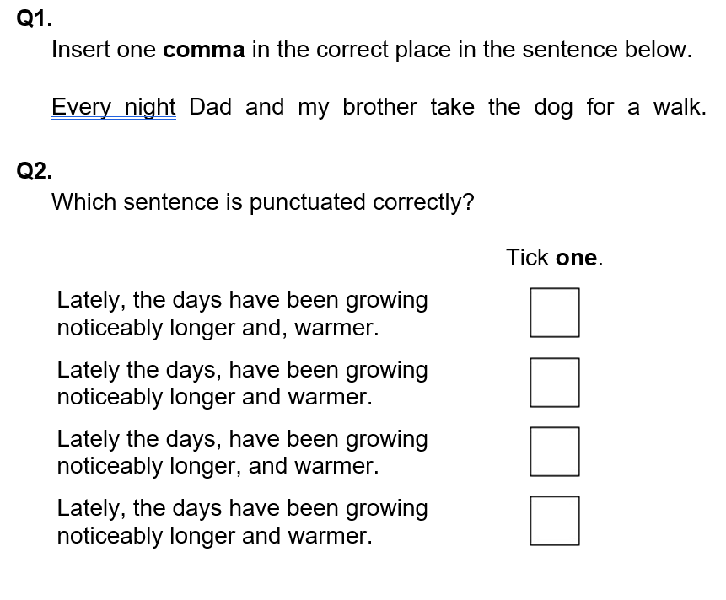
Writing
Write a poem.
Key Skill: Rhyming a,a,b,b,a.

Tick when you have completed this task.

