
Year 5 Homework

Date homework set: 21.11.24
To be returned to school by: 26.11.24


Talking Topic - To discuss the following topic:
“What can I do in the snow?” Try and list ten. Tick when you have completed this task.
Maths Complete your Maths Whizz activity and the task below.
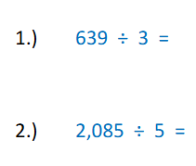
- Times tables Rock Stars.
- Learn your 7 times tables.

Tick when you have completed these tasks.

Reading Read the next chapter from your new reading for pleasure book.
- Continue with your next book mark. Remember when you have completed your book mark, you will receive a certificate and your name will be read out in Friday’s assembly.
- Read to an adult and ask them to sign your Reading Diary.
- Tick when you have completed this task.

Spelling - Practice the spellings below.
Favourite
Different
February
system
symbol
Tick when you have completed this task.
Spag. Complete the activity.
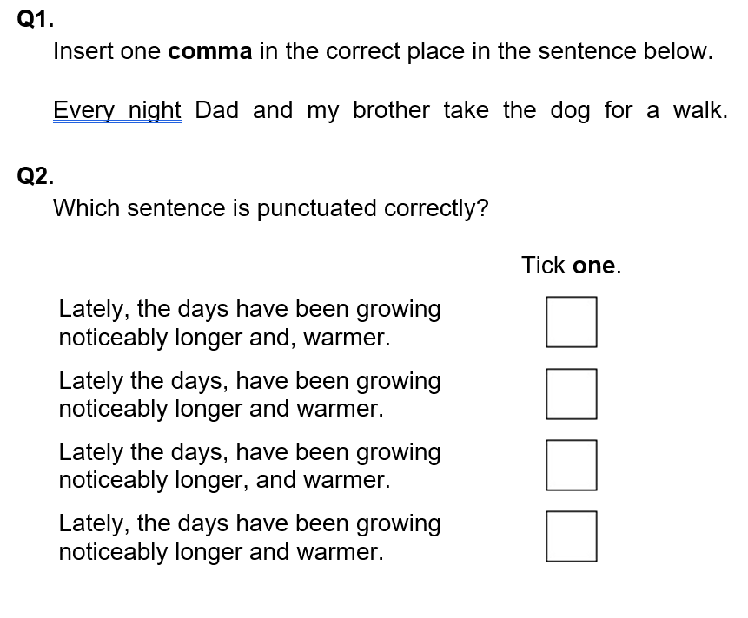

Writing : Write a diary entry as Nick, explaining your feelings about Christmas Day. Tick when you have completed this task.

