
Year 5 Homework

Date homework set: 14.11.24
To be returned to school by: 19.11.24

Talking Topic
- To discuss the following topic:

“Why do people buy a poppy?”
Tick when you have completed this task.
Maths Complete the following, using partitioning and chunking.
- 639 ÷ 3 =
- 2,085 ÷ 5 =
- 1408 ÷ 4 =
- 3850 ÷ 2 =
- Complete 3 steps on Maths Whizz.
- Times tables Rock Stars.
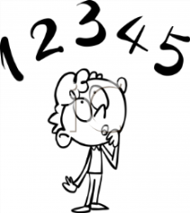
Tick when you have completed these tasks.
Reading

- I want you to complete your Reading for Pleasure book mark.
- Read a book on Bug Club
- Read to an adult and ask them to sign your Reading Diary.
Tick when you have completed this task.

Spelling: Learn this week’s spellings.
Couldn’t
Shouldn’t
Wouldn’t
She’ll
We’ll Tick when you have completed this task.
Spag. Complete the SPAG.com activity, linking ideas with cohesion and the activity below.
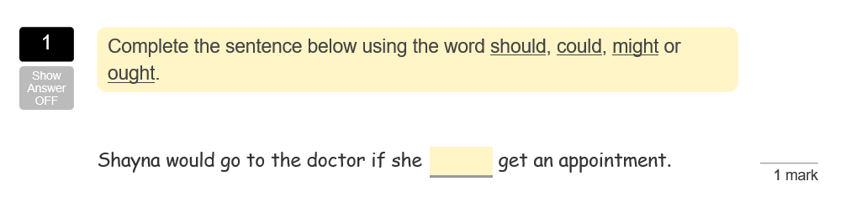
Writing: Key skill, … ing word clause
Write a poem about Pudsey the bear from Children in Need.

Tick when you have completed this task.

