
Year 5 Homework

Date homework set: 7.11.24
To be returned to school by: 12.11.24

Talking Topic
- To discuss the following topic:

“How is Diwali celebrated?”
Tick when you have completed this task.
Maths Complete and learn the following;
- Complete 3 steps on Maths Whizz. I want you to complete this activity, it will help improve your Maths.
- Times tables Rock Stars. Remember the more practice you do the better your maths is. Complete this task.
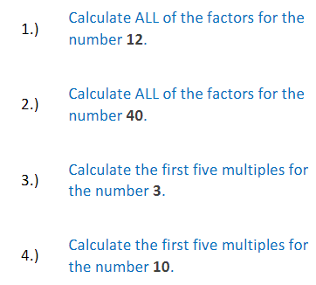
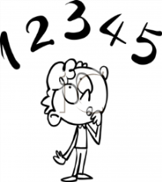
Tick when you have completed these tasks.

Reading: Read the next chapter from your new reading for pleasure book
- Complete your next book mark.
- Read to an adult and ask them to sign your Reading Diary.
Tick when you have completed this task.


Spelling: Learn this week’s spellings and include them in a sentence.
Because
Symbol
Stomach
Desperate
Embarrass
Tick when you have completed this task.
Spag. Com
Complete the SPAG.com activity- cohesion.

Writing - Write a paragraph explaining why light is important when celebrating Diwali. Key skill, include the relative clause- which.
Tick when you have completed this task.

Extra spag activities
Complete each sentence with either is or are.
That perfume expensive.Those shoes Ralph's.The men looking at a car.

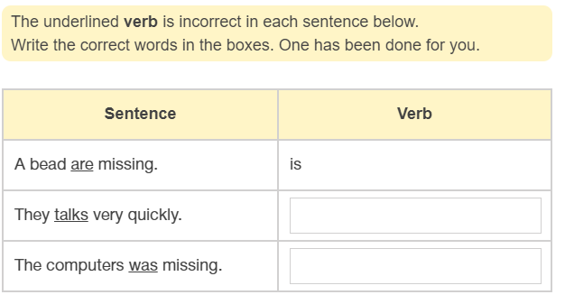

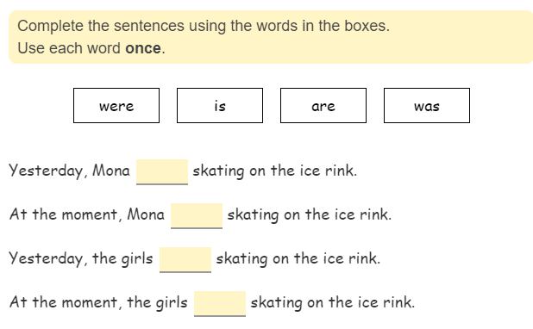

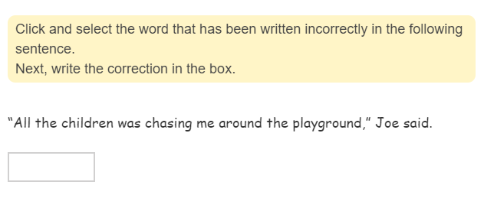

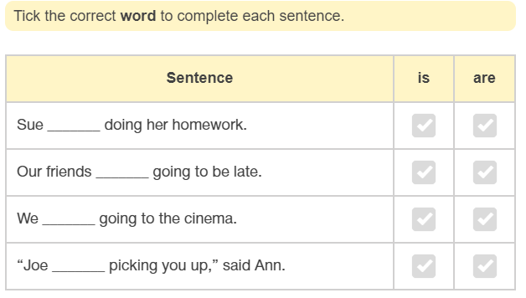

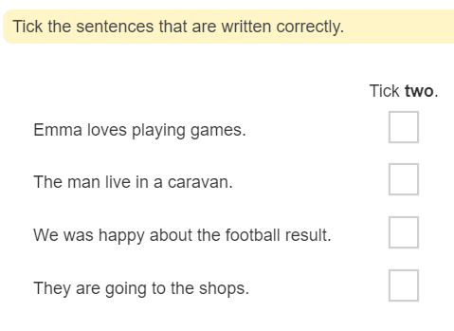

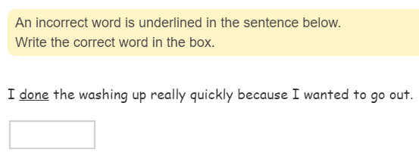
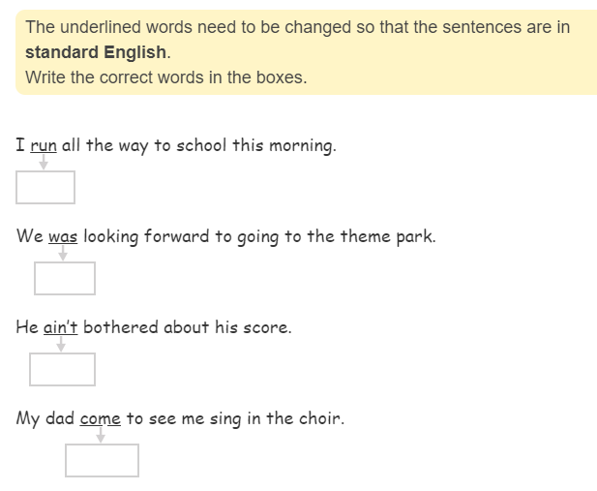

My Maths
