Friday, 01 November 2024
Dear Parents/Carers,
Attendance
Overall our school attendance is 94.94% this week, which is a good improvement.
Y5H Ephemeroptera had the highest attendance this week with 99.26%

Punctuality
Rec K Chick Class and Y3 Mink Class had no lates this week!

Overall, there were 6 hours and 26 minutes of lates.
Lessons start promptly at 8.50am.

Art week
Art Week – thank you to everyone who was able to attend the art week sessions.
Year 5 parents can attend on Tuesday 5th Nov at 2.45pm
The Reception art week session has been changed to Thursday 7th November so that they can have a longer session with lots of exciting events planned. It would be great if Reception parents could join us for this event.

Events That Took Place This Week:
- Rock Kidz – Monday 28th October
All the children that I have spoken to really enjoyed this session, they transformed our hall into a rock concert and turned the children into rock stars for the day.
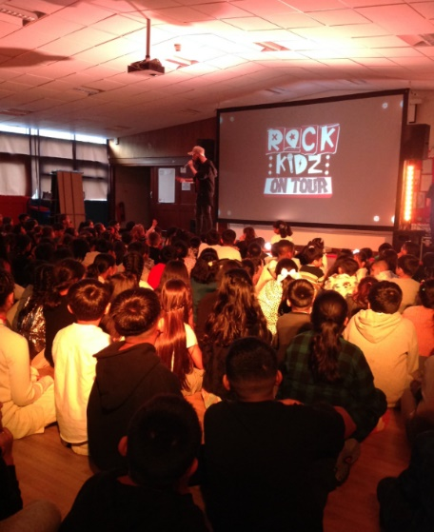
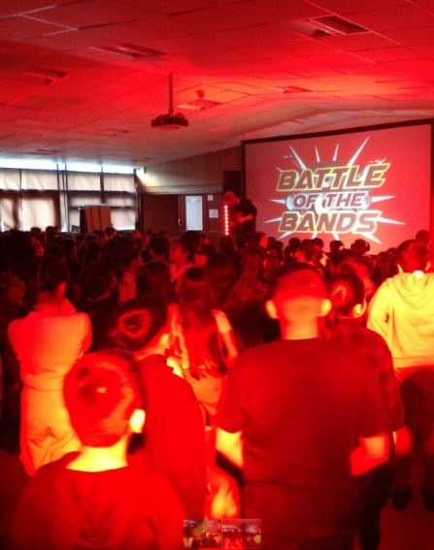
The key message was ‘You Are Awesome, So Be Awesome’. See pictures at the bottom of the page.

- Spooky Bake Sale – thank you to everyone who sent in cakes/biscuits for the bake sale and to those people who bought something from the stall after school.

- School photographs – All the children had their school photograph taken today. When the photographs come into school, we will send them home for you to decide if you want to buy them. It usually takes about a week.

Events Coming Up
- Tuesday 5th November - Y1 trip to the church

- Tuesday 5th November – Sanderson’s Dance School will be working with Y2

- Tuesday 5th November - Y3 are having a visitor from BFC talking about healthy lifestyles

- Wednesday 6th November - BFC are delivering an assembly to children in Y3 – 6

- Friday 8th November - Y5/6 are taking part in an online author visit with award-winning author Hannah Moffat. Her books can be purchased using this link https://hannahmoffatt.com/all-the-order-links-2/

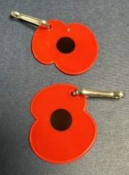
Poppies and merchandise on sale after school
We are selling poppies and other poppy-related merchandise after school.
Poppies and stickers are 20p. Other items range from £1.00 - £1.50
Bracelets and wrist straps are not to be worn in school.
Please bring the correct money as we are unable to give change.

Children can buy one bracelet/wrist strap initially as stock is limited. If there are still items left towards the end of next week, we will let you know that you can buy more.
All proceeds go the Royal British Legion.

Christmas Fair
We will be having our Christmas Fair on Thursday 12th December to raise vital funds for the school. We will be asking for chocolate donations nearer the time, but we are also hoping to get good quality donations for raffle prizes.
If anyone is able to donate anything or works for a company who would be able to do so, please let me know. We would be looking for anything suitable that our families would like to win. This could be vouchers, gifts or other quality items.

Establishing Routines
There is a really good course running in school for parents on Thursday 21st November from 1.45pm to 3.15pm. The focus is on developing good routines, to take away some of the stresses that we all feel when trying to get anything done in the home!
It is free to attend and will be supportive and non-judgemental. There is a leaflet at the bottom of this page. If you want to book on, please call the school office.

Bonfire and Firework Safety

With bonfire night approaching, please remember to ensure that your children are safe when out and about or if you are attending an organised display.
- Only people over 18 are allowed to buy and use fireworks.
- Ensure that children are supervised,
- If children are using sparklers, they should wear gloves and dispose of them in a bucket of water when finished.
- Loose clothing like, tracksuits or scarves can easily catch fire around fires, sparklers or fireworks.

Despite annual safety warnings, Bonfire Night week still ends in disaster for far too many families. Fireworks can provide fun and entertainment, but only if everyone follows the right safety procedures and remembers that fireworks can be very dangerous if misused.

Parent Governor Election
Ballot papers have been sent home for all parents to vote for the new parent governor.
Every adult with parental responsibility for a child at Reedley is entitled to vote.
You should cast your vote and put the ballot paper in the blank envelope.
This should then be placed inside the envelope with a number and stamp, which should be returned to school no later than 11am on 12th November.

Spooky Bake Competition
A huge thank you to the families and staff who took the time to enter the Spooky Bake Competition! There were so many amazing entries with really creative designs. Myself, Mrs Ellis and the School Council spent a lot of time judging – including tasting the entries! See a selection of pictures at the end of this letter.

Children’s category
1st Place – Awais Mahmood Y6
2nd Place – Wania Rashid Y4
3rd Place - Szymon Kycia Y2

Parent category
1st Place – Rabiya Tariq (Aizah/Eshal’s Mum)
2nd Place – Sana Shah (Hashim Khadim’s Mum)

Staff Category
1st Place – Mrs S Daar
2nd Place – Haseeba from school kitchen
3rd Place – Sharon from the school kitchen

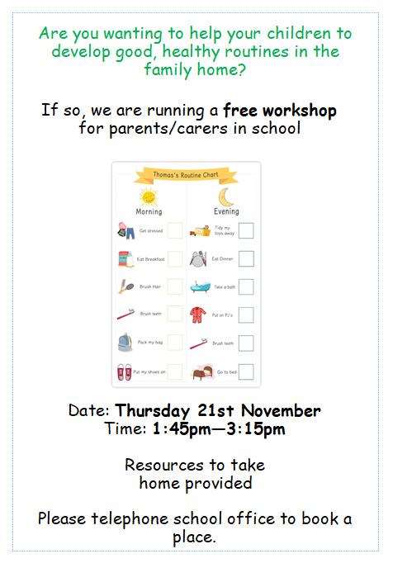


Mrs Sarah Bell
Headteacher

Key Dates

- 14th November – Y4 children going to the cinema.

- BBC Children In Need appeal – wear non uniform and bring £1 on Friday 15th November.

- Friday 29th November – We are asking for donations of chocolate for the tombola for the Christmas Fair

- Thursday 12th December – Christmas Fair 3.45 – 4.45pm

- Friday 13th December – Children’s Christmas dinner

- Friday 20th December – Christmas themed non-uniform day. Bring £2 for school.

- School will be closed from Monday 23rd December for the Christmas holiday, and reopen on Tuesday 7th January.

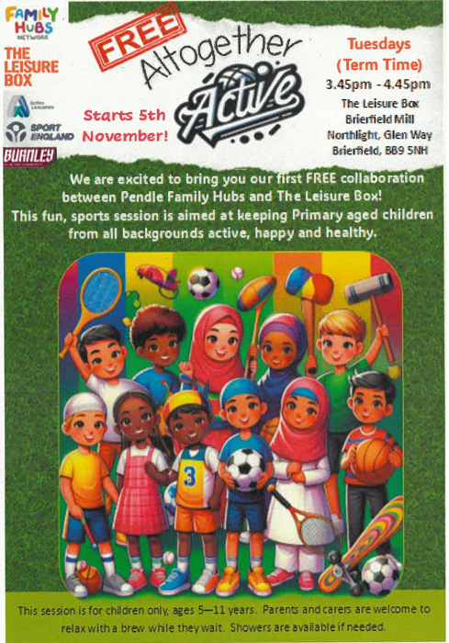

Spooky Cakes
Children’s category – 1st, 2nd and 3rd place
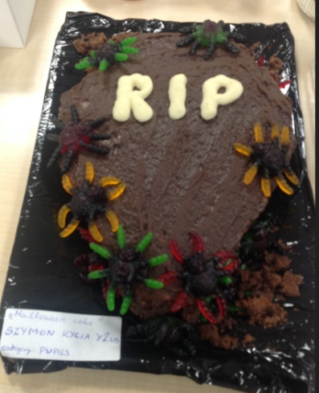
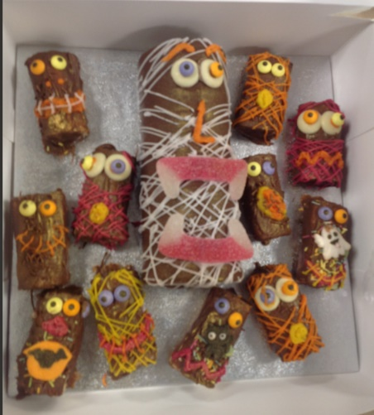
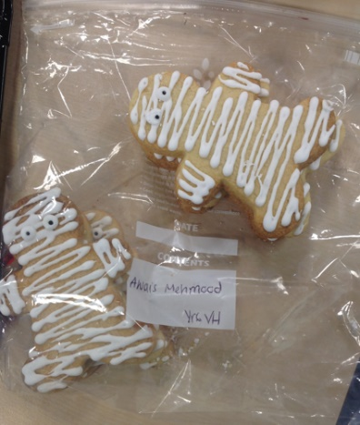

A selection of other fabulous designs (sorry that we couldn’t show them all!)
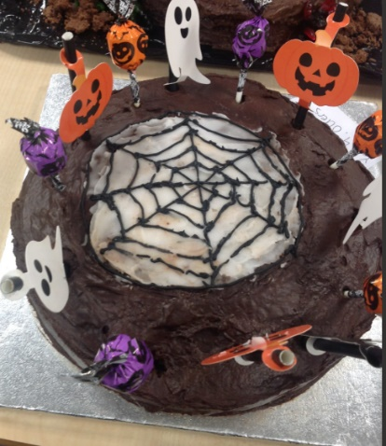
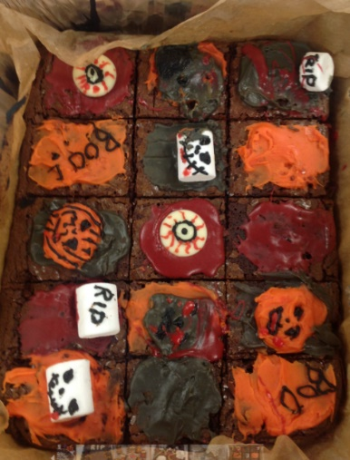
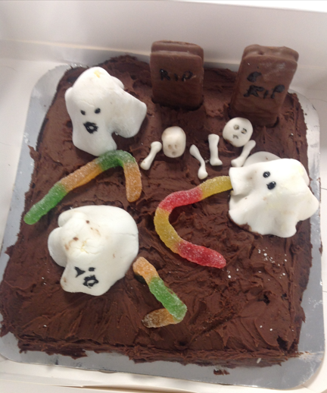

More pictures will be on the School Council section of the website in the next few days!
https://www.reedley.lancs.sch.uk/page/school-council/40536

