Year 5 Homework

Date homework set: 31.10.24
To be returned to school by: 5.11.24

Talking Topic
- To discuss the following topic:
“What was the theme of the Rock concert?”
Tick when you have completed this task.
Maths Complete and learn the following;
- On Maths Whizz, complete the next three steps.
- Times tables Rock Stars. Remember the more practice you do the better your maths will be in Year 5.
- Complete this challenge-
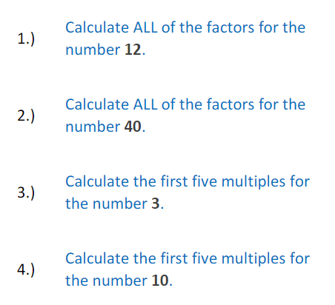
Tick when you have completed these tasks.
Reading
- Read the next chapter from your new reading for pleasure book.
- Read a book on Bug Club
- Continue with your next book mark.
- Read to an adult and ask them to sign your Reading Diary.
Tick when you have completed this task.

Spelling
Learn this week’s spellings and include them in a sentence.
Awkward
Bruise
Category
Cemetery
committee
Tick when you have completed this task.
Spag. Com.
Complete the SPAG.com activity Standard English.

Writing - Write a new short diary as Carrie arriving at her new home for the first time. Key skill, include the relative clause- which.
Tick when you have completed this task.
Spag.com
Complete each sentence with either is or are.
That perfume expensive.Those shoes Ralph's.The men looking at a car.

My Maths

