Friday, 18 October 2024
Dear Parents/Carers,
Attendance
Overall our school attendance is 93.68% this week, which has taken a dip this week.
Red Fox Y4P had the highest attendance this week.

You should have received the traffic light attendance chart next week to enable you to see your child’s attendance for the first half term.
Children who are in the green section at Christmas will be able to watch a magic show in January.

Y4P Red Fox Class have won the attendance treat for the first half term. They will have their non uniform day on Thursday 31st October.

Punctuality
Rec K Chick Class, Y2S Swan Class and Y5H Ephemeroptera Class all had no lates this week!

Overall, there were 4 hours and 20 minutes of lates.
Lessons start promptly at 8.50am.

Y2S Swan Class have won the punctuality award for the first half term. They can have their non uniform day on Thursday 31st October.

Team Points
The Ribble team won the team point competition for the first half term and had their treat this afternoon.

Awards given out today
14 children were nominated by their teacher for the Sue Dean Writing Award. Well done to everyone who received a nomination,
Douaa Bouchrait from Year 5 was awarded this award for this half term.

Children who have taken part in the Reading Awards this half term were entered into a raffle. Adam Baig and Umaima Ihsaan were awarded a £10 book voucher as they won the raffle. If your child wants a chance of winning the book vouchers next half term, they need to take part in the Reading For Pleasure Awards.

Half Term Homework
All children from Y3 to Y6 have a Maths Whizz password. It would really benefit them if they could spend some time working on this. Even 20 minutes a day would make a difference.

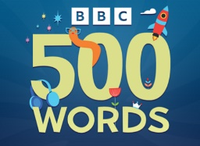
Children can also take part in the BBC 500 words competition. Entries should be given to classteachers, by Tuesday 29th October. Click this link for further details. https://www.bbc.co.uk/teach/500-words
Events That Took Place This Week:
- Y5 children went on a trip to Clitheroe Castle
- Flu Vaccines – if you consented to your child having the flu vaccine, they have received this in school today.
- Thank you to families who met with teachers this week. If you weren’t able to attend and want to make an appointment to do so, please call the school office.
- Y4 had a fantastic Lego workshop.
If your child is in Y4 and you haven’t contributed your £2 towards this workshop, please can you send the money into school. These events cost around £400 for every workshop. Without your contributions, we won’t be able to run events such as these.
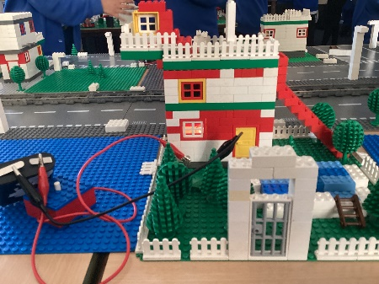
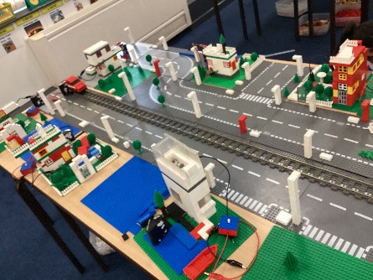
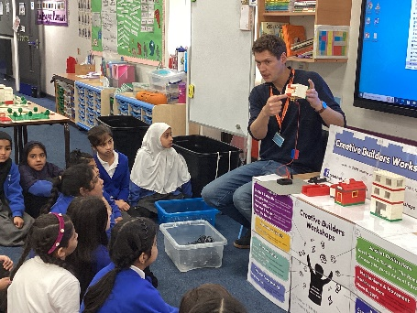

Events After Half Term
- Art Week – see sessions throughout the week
- Rock Kidz – Monday 28th October
- Spooky Bake Sale – Friday 1st November
- School photographs – Friday 1st November – family pictures can be taken from 8.15am

Art week sessions
Families are invited into school at the following times to see what their child is learning in art week and maybe to have a go at a bit of art work themselves.

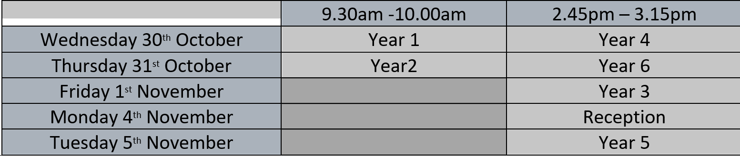

YEAR 6 – Families of children in Year 6 must apply for a high school place no later than 31 October. If you do not apply for the high school of your choice, you can be allocated any school and it may not be near to home.
You must apply online and you will need to make an account and enter an email address.
https://www.lancashire.gov.uk/children-education-families/schools/apply-for-a-school-place/starting-secondary-school/

Spooky Bake Competition
You are invited to take part in our Spooky Bake Sale, designed to have fun and raise money for Reedley School.
On Friday 1st November we are asking children and families to bring in cakes and biscuits that they have made at home. If you like, these can have a spooky theme. Please ensure that all entries are labelled with the name of the baker and which category it is being entered in.

There will be three categories: Pupils, staff and parents.

These will be judged and the top 5 will win a certificate.
Cakes/biscuits will then be on sale at the end of the school day – so please come along and support the school in this fun event.
Please ensure that all items are suitable for vegetarians.




Rock Kidz are visiting our school on Monday 28th October.
We are asking all staff and pupils to dress as a pop or rock star for the day.
Please ensure all outfits are appropriate for a day in school.
Don’t forget that they will be selling merchandise after school.


T-Shirts - £12
Caps - £15
Hoodies - £20

They will accept cash and card payments.

Soccer School
Soccer school will be running throughout half term for children that have been booked onto the course.
Sessions start at 9am and end at 4pm.
All children need to bring a healthy packed lunch, an extra drink and appropriate sport kit, including a coat for if they go outside. They will not be able to access any kit in school.
The session is being run by Pro Sport Coaches. Their contact number will be displayed in school when you arrive, so please make a note of it as there will be no-body in the school office.
You must drop your children off with the coaches. Please do not send them in on their own.

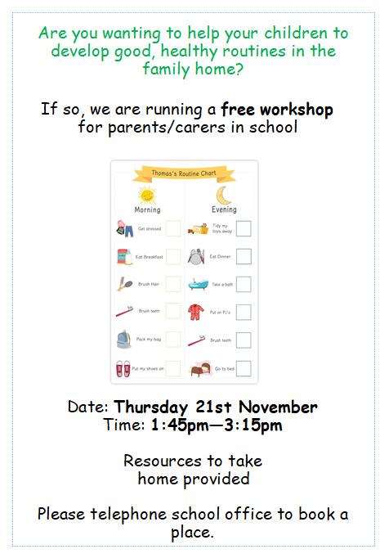

Thank you for your support and have a lovely half term. See you all on Monday 28th October.
Mrs Sarah Bell

Headteacher

Key Dates
- School will be closed from Monday 21st October to Friday 25th October for half term.

- Art week – week beginning Monday 28th October. Parents/carers will be invited into school for designated slots.

- Monday 28th October - Rock Kidz On Tour are visiting school. On this day children can dress as a rock or pop star or just in non-uniform if they prefer. Please ensure that all outfits are appropriate and suitable for school.

- School photographs will be on Friday 1st November

- Spooky Bake Sale on Friday 1st November

- BBC Children In Need appeal – wear non uniform and bring £1 on Friday 15th November.

- School will be closed from Monday 23rd December for the Christmas holiday, and reopen on Tuesday 7th January.

