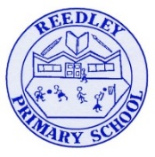
Year 5 Homework
Date homework set: 17.10.24
To be returned to school by: 28.10.24


Talking Topic To discuss the following topic:
“What can we do with our empty plastic bottles?” Tick when you have completed this task.
Maths : Complete the task below.
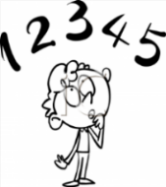
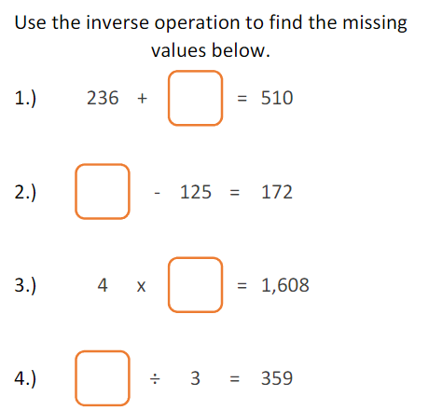
When you have completed the above Maths complete 3 steps on Maths Whizz. https://whizz.com/
Tick when you have completed these tasks.

Reading: Read the next chapter from your new reading for pleasure book. Ask someone to listen to you read.
- Complete your next bookmark.
Tick when you have completed this task.
Spelling : Learn this week’s spellings. Include them in a sentence.
Incredible
Sensible
Reliable
respectable
Tick when you have completed this task.
Spag. Complete the activity on SPAG. Com. Verbs in perfect form. https://www.spag.com
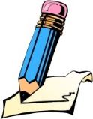
Writing. Writing - BBC 500 words competition. Last week. Mrs Gorrell, set you your writing task, see you below. This week I want you to read through your work and edit, making it even better. What other details could you add?
- It’s very simple. Write an original story on any subject or theme in 500 words or fewer and return to school with your homework. The best entry from each class will be entered into the competition.
- 50 finalists from the competition, along with their parents or carers, will be invited to attend a grand final next February at Buckingham Palace! The Bronze, Silver and Gold winners of each age group will have their stories read by lots of celebrities.
- Mrs Gorrell is an experienced judge for the BBC 500 words competition and is looking forward to reading your stories.
- If you wish to send your entry from home, you can find out more about the competition here:
https://www.bbc.co.uk/teach/500-words/articles/zqc8mbk

