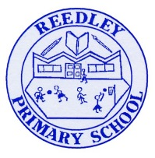
Mock Homework

Date homework set: Thursday 10th October
To be returned to school by: Tuesday 15th October


Talking Topic
- To discuss the following:
Look at some of the different foods you have in your house. Where did it come from? Which food has come from the furthest /nearest place?

Tick when you have completed this task.
Maths
- Learn these number facts:
4x9=36 6x9=54 12x9=108 3x9=36
- Practise counting on in 10s from 3.
- Whizz.com Complete three steps on addition and subtraction.
Tick when you have completed these tasks.
Spelling, grammar and punctuation

Complete expanded noun phrases activity on https://www.spag.com/
Log in and complete the activities. Tick when you have completed these tasks.
Learn the following spellings and put each one in a sentence.
There
Their
Where
Were

Writing - BBC 500 words competition.
- It’s very simple. Write an original story on any subject or theme in 500 words or fewer and return to school with your homework. The best entry from each class will be entered into the competition.
- 50 finalists from the competition, along with their parents or carers, will be invited to attend a grand final next February at Buckingham Palace! The Bronze, Silver and Gold winners of each age group will have their stories read by lots of celebrities.
- Mrs Gorrell is an experienced judge for the BBC 500 words competition and is looking forward to reading your stories.
- If you wish to send your entry from home, you can find out more about the competition here:

https://www.bbc.co.uk/teach/500-words/articles/zqc8mbk

Good Luck and happy story writing!

Tick when you have completed this task.

