
Year 5 Homework
Date homework set: 26.9.24
To be returned to school by:27.9.24

Talking Topic
- To discuss the following topic:

“Why is forgiveness important?”
Tick when you have completed this task.
Maths – Complete maths whizz and times table rock stars and the activity below.
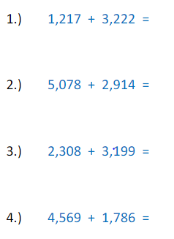

Tick when you have completed these tasks.
Reading

- Read the next chapter from your new reading for pleasure book.
- Complete your next bookmark.
- Complete the book on Bug Club.
Tick when you have completed this task.
Spelling : Write a sentence for each spelling below, don’t forget the silent letter.

Muscle
Rhyme
Rhythm
yacht Tick when you have completed this task.
Spag. Complete the activity- expanded noun phrases on spag. Com.
Writing- I want you to write a descriptive setting of the picture below. Key skill- extended noun phrases.




