
Year 5 Homework

Date homework set: 14.9.23
To be returned to school by: 19.9.23

Talking Topic: To discuss the following topic:

“What is diversity?”
Tick when you have completed this task.
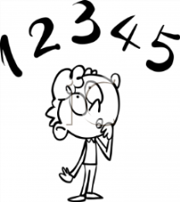
Maths : On My Maths, complete the next three steps of Place Value on Maths Whizz. whizz.com
Learn your eight times tables.
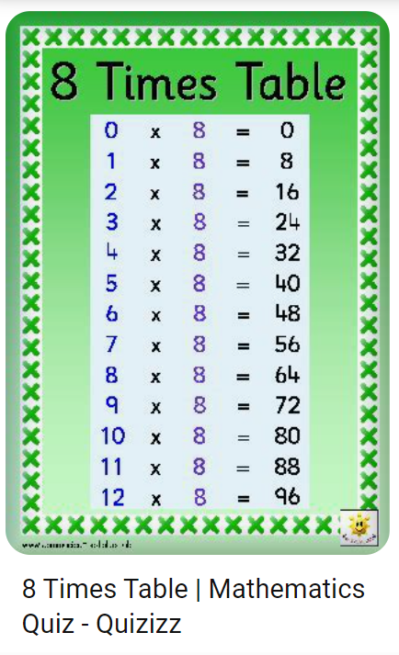

Reading: Read the next chapter from your new reading for pleasure book. Ask someone to listen to you read.
- Complete your next 3 sections of your book mark.
Tick when you have completed this task.
Spelling : Learn this week’s spellings. Include them in a sentence.
Although
Tough
Sought
Bought
Tick when you have completed this task.
Spag. Complete the activity on SPAG. Com. Subordinate clauses and conjunctions. https://www.spag.com
Writing: I want you to describe the castle, your key skill is including a main clause and a subordinate clause.

Reminder:
If you would like extra homework there are more activities on:
Times Tables Rock Stars – Times Tables Rock Stars (ttrockstars.com)

