
Year 5 Homework
Date homework set: 4.9.224
To be returned to school by: 10.9.24

Talking Topic : To discuss the following topic:

“Why is learning to swim important?”
Tick when you have completed this task.

Maths : Complete your Mathswhizz activity – Place value of numbers.
https://whizz.com
Learn the place value meaning.

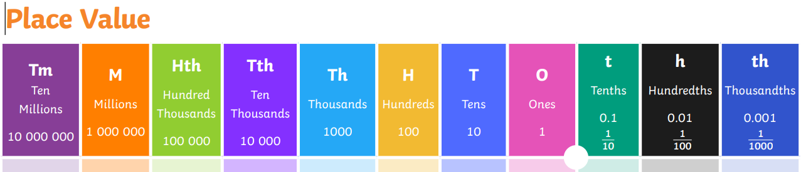
Practice your times tables on Times Table Rockstars. ttrockstars.com


Reading : Read the next chapter from your new reading for pleasure book. *Ask someone to listen to you read.
*Complete three sections of your bookmark.
Tick when you have completed this task.
Spelling : Learn this week’s spellings. Include them in a sentence.
Anxious
Famous
Nervous
dangerous
Spag. Complete the activity on SPAG. Com. Standard English. https://www.spag.com
Writing: Write a new story about the picture below. Your writing focus is to write in sentences that make sense.

Think about: Why is that giraffe so big? Who is that boy? Where are they?

