Progression in Written Multiplication | Stage 1 - EYFS  Children are encouraged to develop a mental image of the size of numbers. They learn to think about equal groups or sets of objects in practical, real life situations.  They begin to record these situations using pictures.  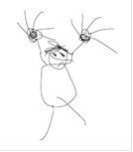  A child’s jotting showing fingers on each hand as a double.  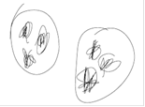  A child’s jotting showing double three as three cookies on each plate. | Stage 2 – Year 1 &Year 2  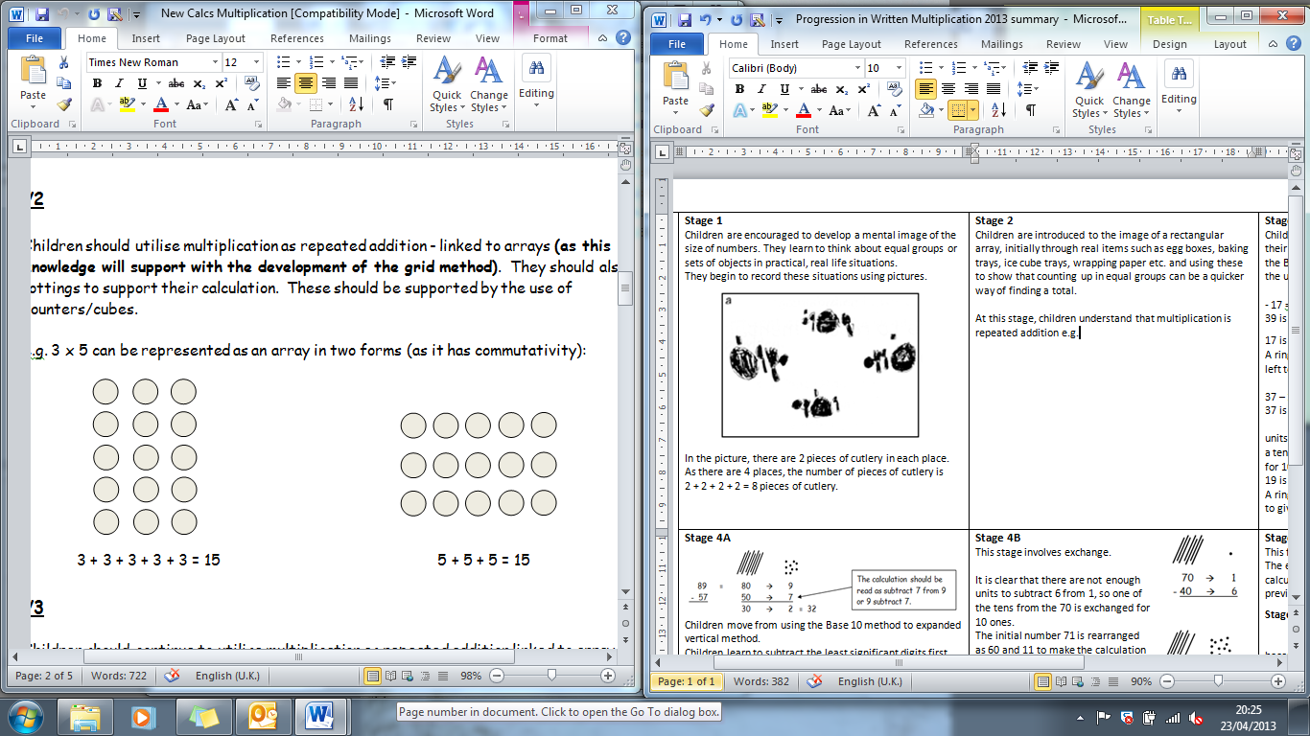  Children understand that multiplication is repeated addition and that can be done by counting in equal steps/groups.  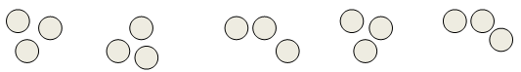  or  Children can then be introduced to the image of a rectangular array, initially through real items such as egg boxes, baking trays, ice cube trays, wrapping paper etc. and using these to show that counting up in equal groups can be a quicker way of finding a total.  Children also understand that  3 x 5 is the same as 5 x 3  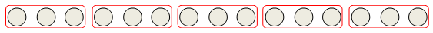 | Stage 3 – Year 3  Children continue to use arrays and create their own to represent multiplication calculations  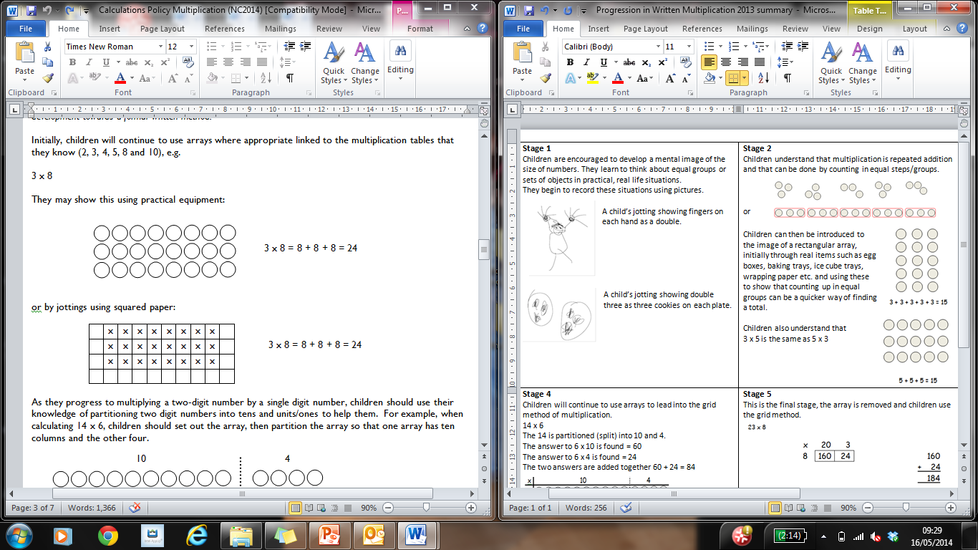
Progression in Written Multiplication | Stage 4 – Year 3  Children will continue to use arrays to lead into the grid method of multiplication.  14 x 6  The 14 is partitioned (split) into 10 and 4.  The answer to 6 x 10 is found = 60  The answer to 6 x 4 is found = 24  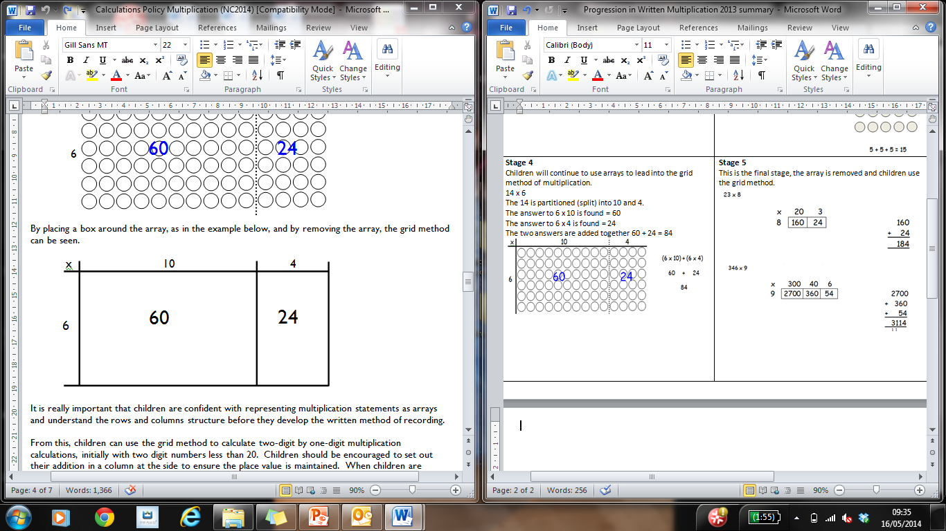  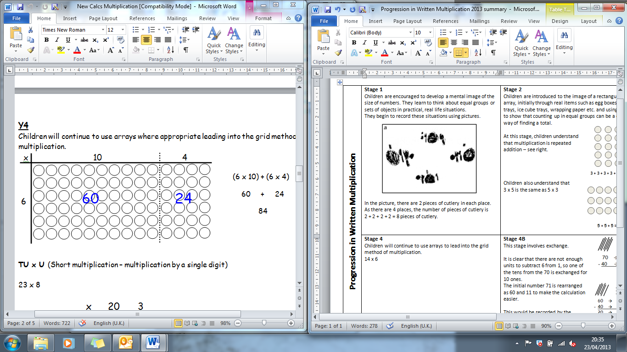  The two answers are added together 60 + 24 = 84 | Stage 5- Year 3 & Year 4  In this stage, the array is removed and children use the grid method. This is an important step in retaining children’s understanding of multiplication.  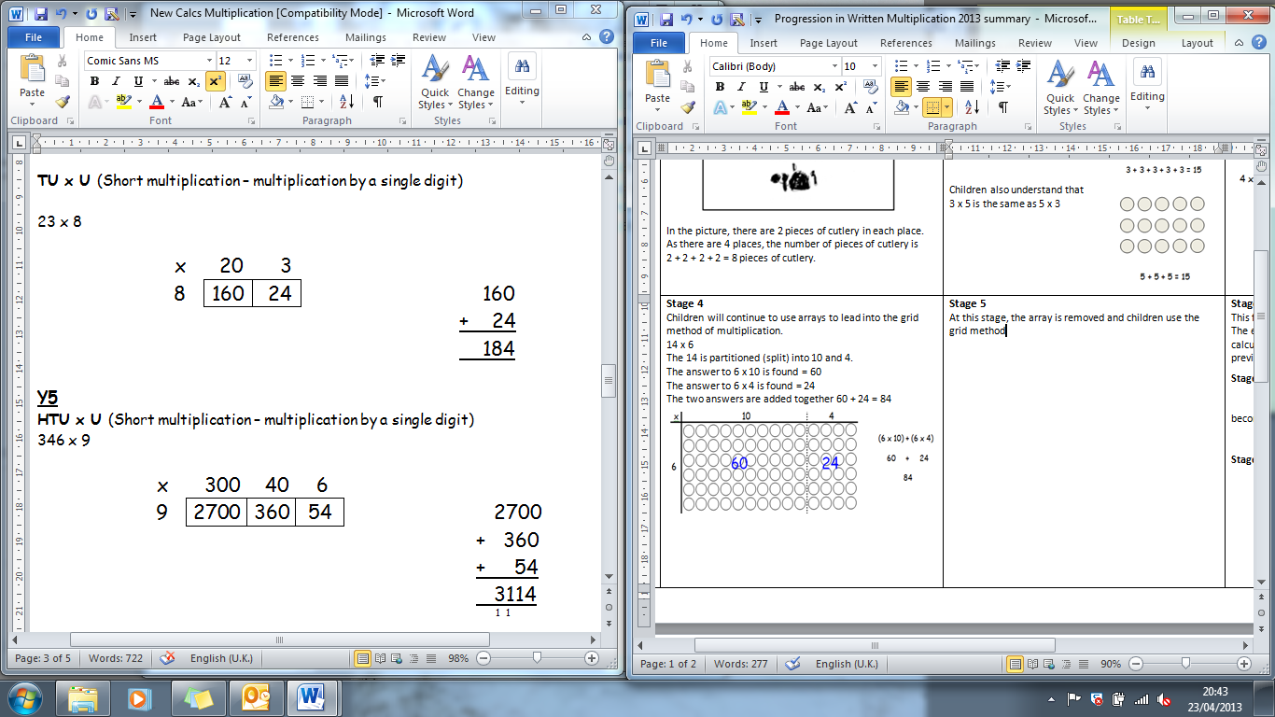 | 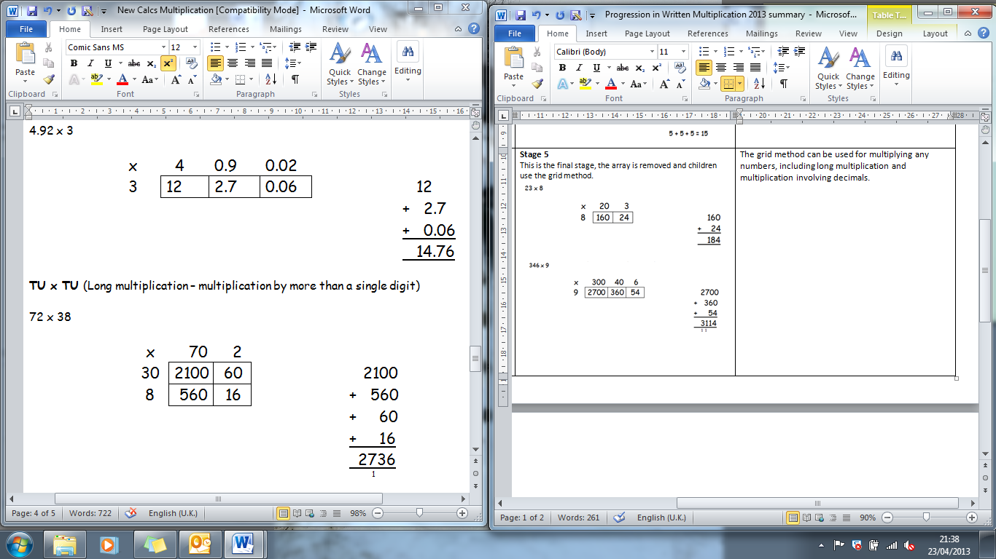  The grid method can be used for multiplying any numbers, including long multiplication and multiplication involving decimals.
Progression in Written Multiplication | 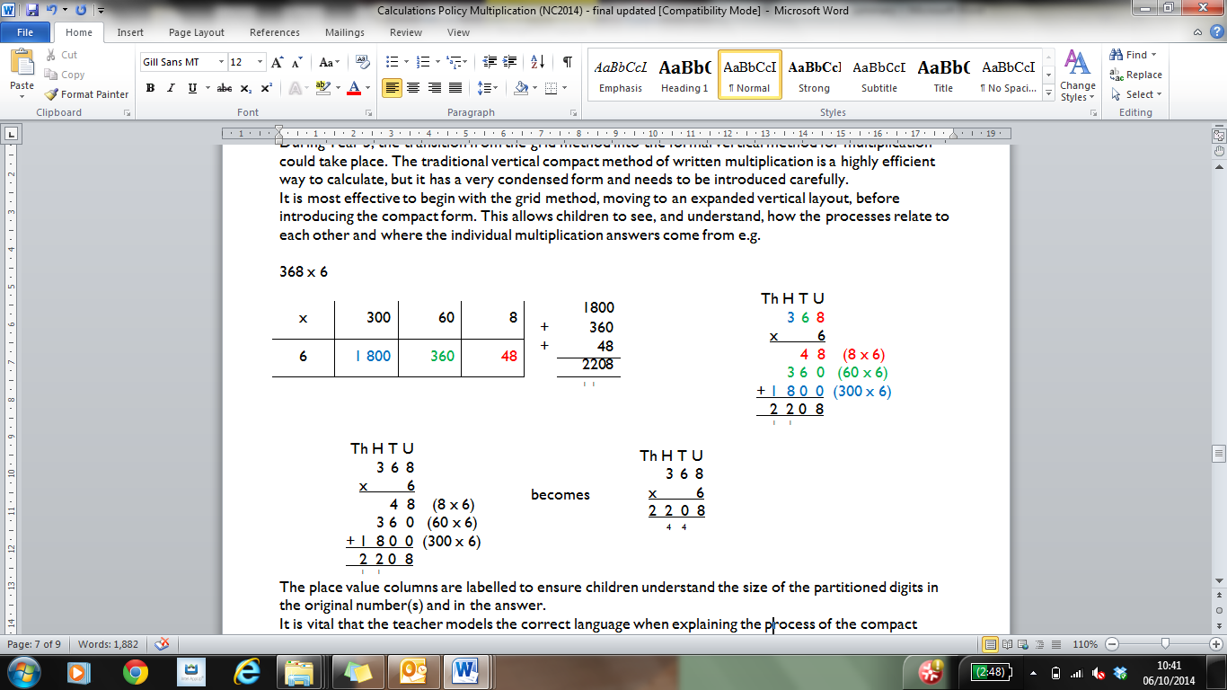  Stage 6 – Year 5  The grid method should then be taken into an expanded vertical layout. | Stage 7 – Year 5 & Year 6  The expanded method should then be taken into the compact vertical method.  The place value columns are still labelled to ensure children understand the value of each digit in the original number and the answer. | Stage 8 – Year 5 & Year 6  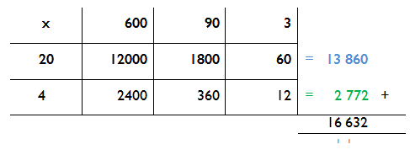  The vertical method for long multiplication builds on children being efficient when using grid method.  Mental addition of the top and bottom rows separately will help children identify these answers in the vertical method.  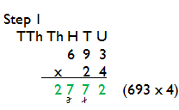  Again the place value columns are labelled to support children in understanding the value of the digits in the original numbers and in the answer.  As with other calculations,  start with the least  significant digit, which  means we are doing the  equivalent of the bottom  row of the grid method  from right to left.  Carried digits are crossed out to avoid confusion as the method continues.  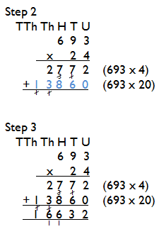  The next step is multiplying  by the multiple of 10. This  is equivalent to the top row  of the grid method.  Therefore, if the answer  has 2 digits, this is simply  put in the correct place.  Whereas if the answer has  3 digits, the TU digits are  put into the answer and the  H digit is carried into this  column.  The final step is to add the  two answers together.
Progression in Written Multiplication | Children should not be made to go onto the next stage if:  - they are not ready.  - they are not confident.  Children should be encouraged to consider if a mental calculation would be appropriate before using written methods.

