Date homework set: 11.06.24
To be returned to school by: 19.06.24


Talking Topic: To discuss the following topic:
“Who was the Highwaymen? ”
Tick when you have completed this task.
Maths Complete the following
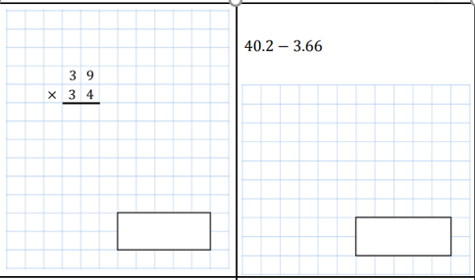
- Complete the next three steps on Maths Whizz
Complete TTRockstars.
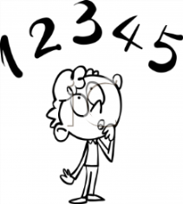
Tick when you have completed these tasks.

Reading Read the next chapter from your new reading book and you must complete the next book mark.
- Continue reading your book on bug club. This activity is part of your homework.
- Read to an adult and ask them to sign your Reading Diary.
Tick when you have completed this task.

Spelling: Learn this week’s spellings.
different, which, ceiling, receive, receipt, deceive
Tick when you have completed this task.
Writing: Write a description about the character, The Highwayman.
Key Skill : Simile sentence starters. 