
Year 5 Homework

Date homework set: 24.4.24
To be returned to school by: 30.4.24

Talking Topic

- To discuss the following topic:
“What is climate?”
Tick when you have completed this task.
Maths Complete and learn the following;
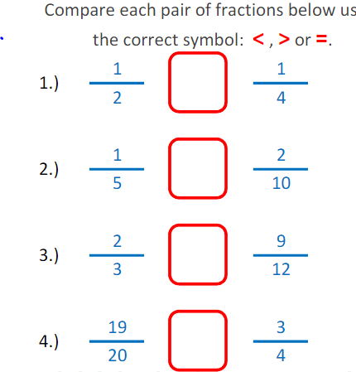
- On My Maths, completes. Adding and subtracting fractions.
- Complete TTRockstars.
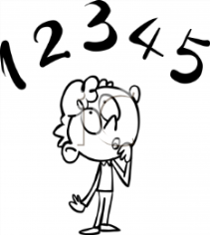
Tick when you have completed these tasks.

Reading Read the next chapter from your new reading book and you must complete the next book mark.
- Continue reading your book on bug club. This activity is part of your homework.
- Read to an adult and ask them to sign your Reading Diary.
Tick when you have completed this task.

Spelling
Learn this week’s spellings.
soldier
stomach
sufficient
suggest
symbol

Tick when you have completed this task.
Spag.
Complete SPAG.com.
Activity- Apostrophes and Plural (A)
Writing
Write a story about this picture and give your story a name


Key Skill: Simile sentence starter.

Tick when you have completed this task.

