
Year 5 Homework

Date homework set: 18.04.24
To be returned to school by: 23.04.24
When completing your homework try and do a little every day and not all at once.

Talking Topic

- To discuss the following topic: What would you like to achieve in the future?

Tick when you have completed this task.
Maths
Complete the activity below. Find the mean of each question.
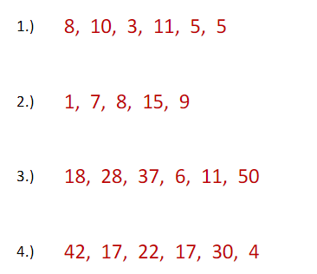

Times tables Rock Stars.


Tick when you have completed these tasks.
Reading

- Read the next chapter from your new reading for pleasure book.
- Read a book on Bug Club
- Continue with your next book mark.
- Read to an adult and ask them to sign your Reading Diary. Your reading diary will be checked.
Tick when you have completed this task.

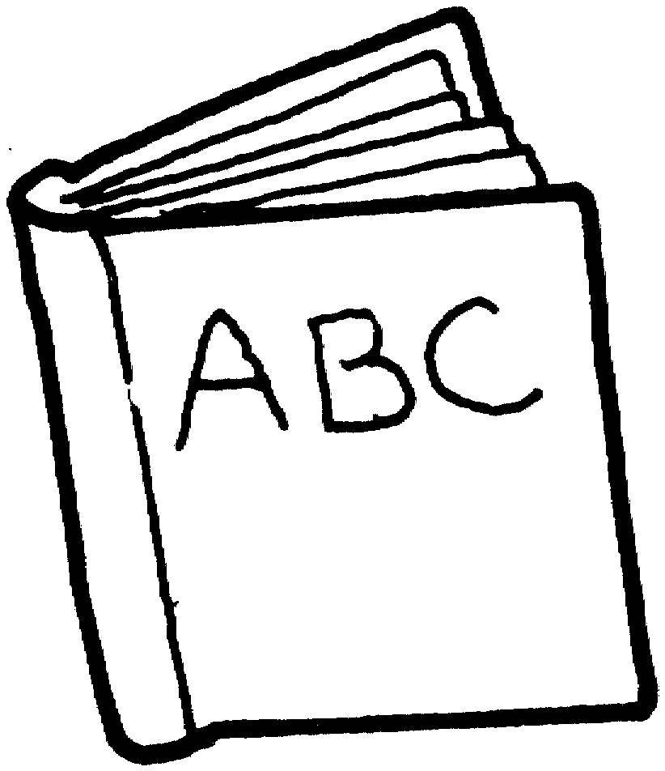
Spelling
Learn this week’s spellings
- Necessary
- Neighbour
- Nuisance

- Occupy
- Occur

Tick when you have completed this task.
Spag – Standard English.
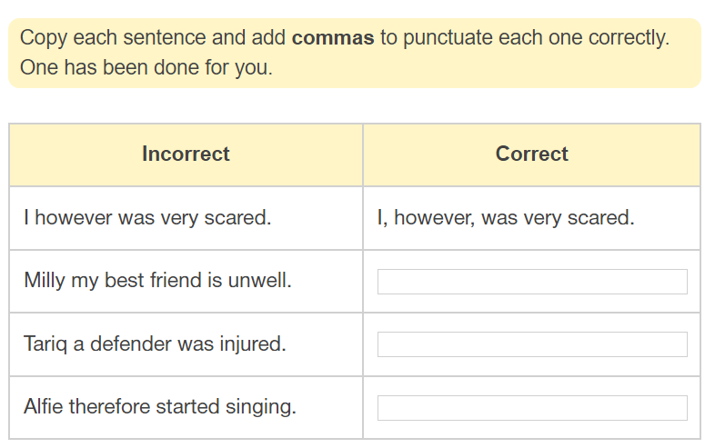
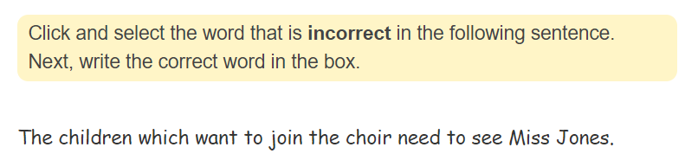
Writing. Skill: Complex sentences



