Rainforest Vocabulary |  |  |  | Henri Rousseau Art
Amazon Basin | The Amazon Basin is the part of South America drained by the Amazon River and its tributaries. Most of the basin is covered by the Amazon Rainforest, also known as Amazonia. | 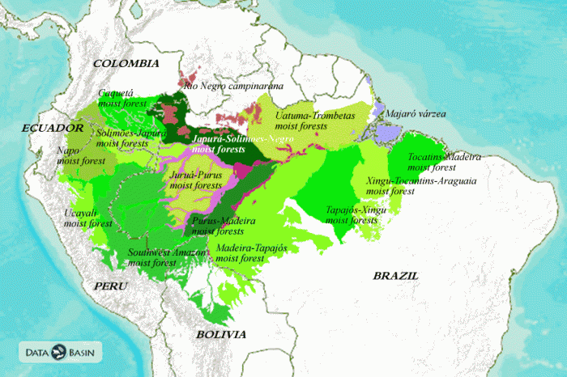  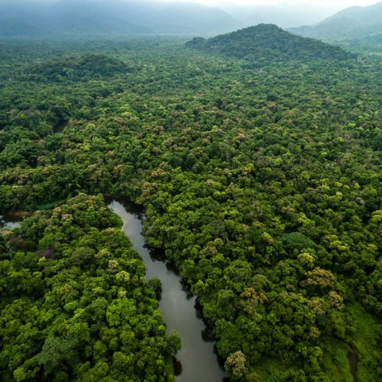  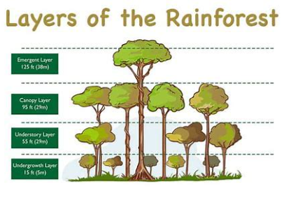 |  | Composition | Composition is the arrangement or placement of visual elements in a piece of artwork. You might consider this exactly the same as the “layout” of a piece
Biome | A biome is a large region of Earth that has a certain climate and certain types of living things. The plants and animals of each biome have traits that help them to survive in their particular biome. |  |  | Scale | Scale refers to the overall physical size of an artwork or objects in the artwork.
Continent | Any of the world's main continuous expanses of land (Europe, Asia, Africa, North and South America, Australia, Antarctica). |  |  | Proportion | Proportion refers to the dimensions of a composition and relationships between height, width and depth.
Vegetation | Plants considered collectively, especially those found in a particular area or habitat | 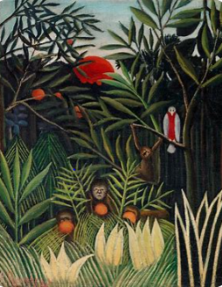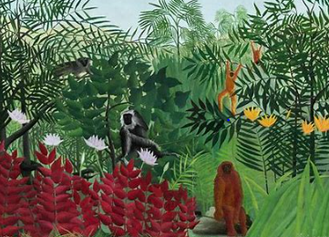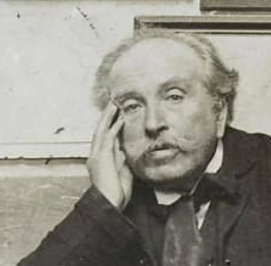  Henri Rousseau Art. |  | Over lay | Overlay is a term that is used to refer a coating of paint laid over to conceal another surface. It can also be a cover sheet which is transparent containing image, corrections, separations or directions that is put over another image to create a fused image.
Science Vocabulary |  |  | Signs and Symbols
Mammal | A warm-blooded vertebrate animal of a class that is distinguished by the possession of hair or fur, females that secrete milk for the nourishment of the young, and (typically) the birth of live young. |  | 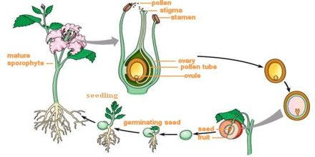  The life cycle of a flower
Amphibian | A cold-blooded vertebrate animal of a class that comprises the frogs, toads, newts, salamanders, and caecilians. They are distinguished by having an aquatic gill-breathing larval stage followed (typically) by a terrestrial lung-breathing adult stage.
Stamen | The male fertilizing organ of a flower, typically consisting of a pollen-containing anther and a filament.
Stigma | The part of a pistil that receives the pollen during pollination.
Germination | The development of a plant from a seed or spore after a period of dormancy.
David Attenborough | David Attenborough is a well-known wildlife presenter and animal expert. After studying the natural sciences at the University of Cambridge, he began his career as a producer at the BBC, where he launched the successful Zoo Quest series.
Jane Goodall | A British anthropologist and primatologist, Jane Goodall is the world's leading authority on chimpanzees. Goodall is famous for her work among the chimpanzees of Gombe and for her efforts to raise awareness about the plight of both wild and captive chimpanzees.

