
Year 5 Homework

Date homework set: 6.2.24
To be returned to school by: 20.2.24
When completing your homework try and do a little every day and not all at once.

Talking Topic
- Talk to an adult about how the moon appears to change shape over the month. Include these words: new moon, first quarter, full moon, third quarter.

Tick when you have completed this task.
Reading

- Read the next chapter from your new reading for pleasure book.
- Read a book on Bug Club
- Continue with your next book mark.
- Read to an adult and ask them to sign your Reading Diary. Your reading diary will be checked.
Tick when

Spelling: Learn this week’s spellings and include each one in a sentence.
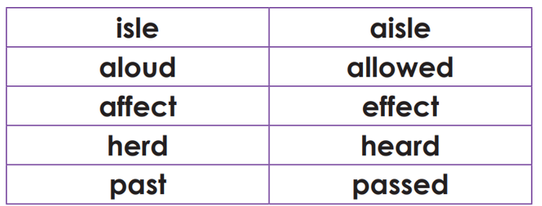

Tick when you have completed this task.
Maths
Learn these prime numbers
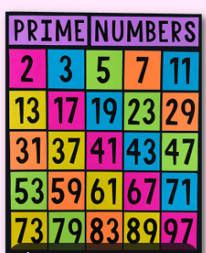
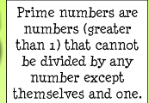
Complete Times tables Rock Stars.
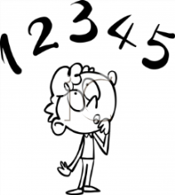
Tick when you have completed these tasks.
Research:
- Write a paragraph about how the moon appears to change shape over the month. Include these words: new moon, first quarter, full moon, third quarter, waxing (growing) crescent and waning (shrinking) crescent.


Tick when you have completed this task.

