
Year 4 Homework – Starling class and Kingfisher class
Date homework set: Thursday 21st December 2023
To be returned to school by: Tuesday 9th January 2024

Talking Topic (10 min)
Enjoy time to talk


Tick when you have completed this task.
Maths (10 min)

A range of activities have been set on Purple Mash for you to complete.
Don’t forget to keep practising your times tables. Mrs Bell would love to hand out more certificates in the new year.

English (10 mins)

Spellings

Practise the Year 3 and 4 spellings below using some spelling strategies we use in class. If you would like to practise more, the spelling list can be found on our class page.
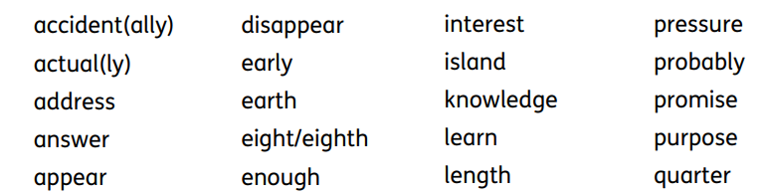


. Battle of the classes!
Year 3 and 4 TTRockstars battle will take place from Thursday 21st December to 9th January 2024

