
Year 4 Homework – Starling class and Kingfisher class
Date homework set: Thursday 21st September 23
To be returned to school by: Tuesday 26th September 2023


Talking Topic (10 min)
Talk to a family member or a friend about what we can do to help save our planet. Think back to Miss Radcliffe’s
assembly about recycling. Perhaps have a think about what you could do at home or at school.

Tick when you have completed this task.
Maths (10 min)
This year, Year 4 children will be taking part in the Multiplcation Maths Check. Therefore, we would like them to practice their times tables as much as possible so that they are confident when the check comes around.
Please use the link below to practice as it is a similar format to the one used during the formal check.
MTC Test - URBrainy

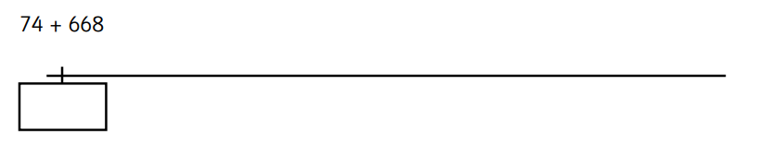
We have been looking at addition and subtraction using a numberline this week. Have a go with these.

458+ 273=

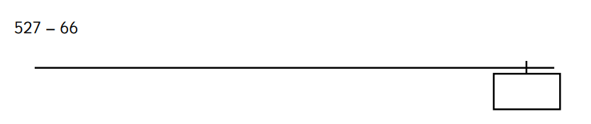

743 – 328 =

Tick when you have completed this task.

English (10 min)

Re-write these noun phrases as expanded noun phrases. (Think about how we described the Fire-Fiend!)

The dog

An ice-cream

The haunted house

A car

Tick when you have completed this task.

Other tasks that could be completed;
. Practice Year 3/4 spellings.
. Times Tables Rockstar’s
. Purple Mash
. My Maths
. Read your reading book or Reading for Pleasure book.
. Complete the reading for pleasure book marks.
. Spag.com
. Bug Club

