
Year 5 Homework

Date homework set: 25.05.23
To be returned to school by: 06.06.23

Talking Topic (10 minutes)
- To discuss the following topic:

- “Would you like to go to the Amazon Rainforest as a holiday? Why”
Tick when you have completed this task.
Maths (10 minutes)
Complete the following:
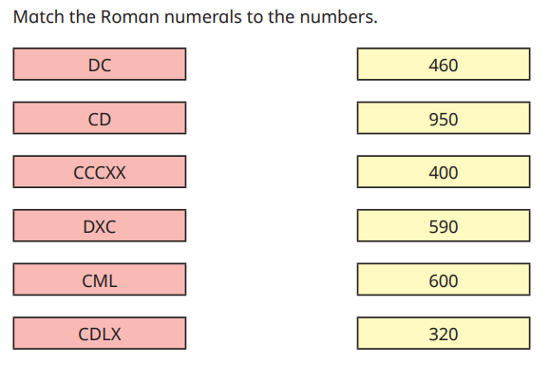
Tick when you have completed these tasks.
Writing (10 minutes)
Write a story with this beginning:


Spellings:
Accommodate
Accompany
According
Achieve
Aggressive

