06/03/23 | Prefix ‘un’
 | Mr Cucumber was unhappy because he was wrapped up in toilet paper.  The Evil Pea was being unfair on the veggies.  The veggies felt unsafe in the supermarket.
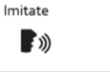 | I am feeling ______well.  He was being _____kind.  Supertato was _____afraid
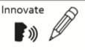 | I am feeling ______________.  He was being ______________.  Evil Pea was ______________.
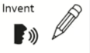 | Write your own sentences using an ‘un’ word

unclean | unplug | unhappy | unwell
unlucky | unwrap | unkind | unlock
undo | unstick | untidy | unpack
unsafe | unzip | unfair | unafraid

