Friday 10th March 2023
KL: To be able to identify and label basic parts of a tree.

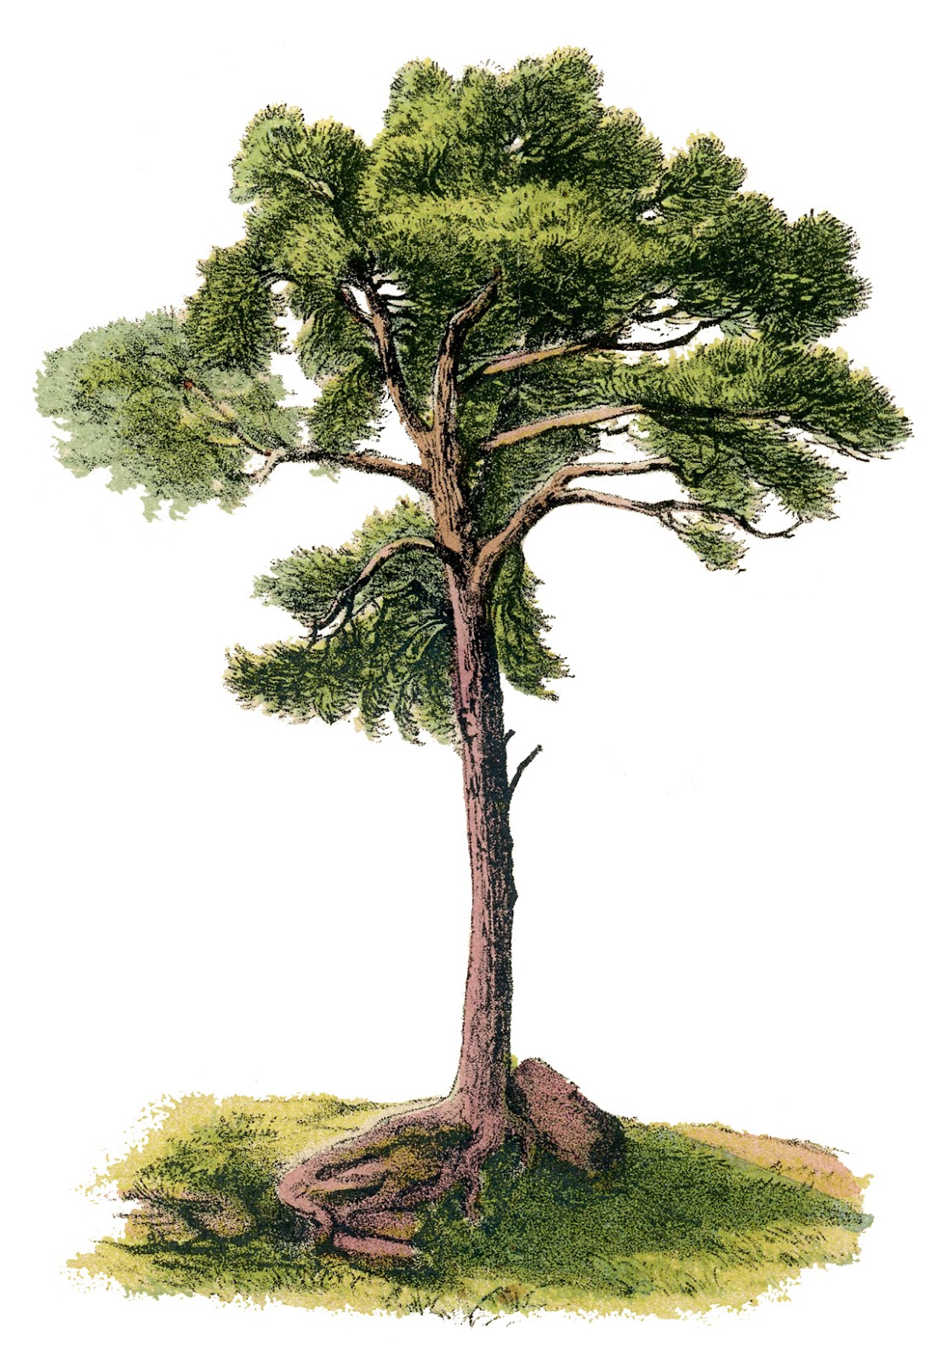

leaves
trunk
roots
branch

Friday 10th March 2023
KL: To be able to identify and label basic parts of a tree.

CHALLENGE: Why are the roots important?

____________________________________________________________________________________________________________
______________________________________________________

